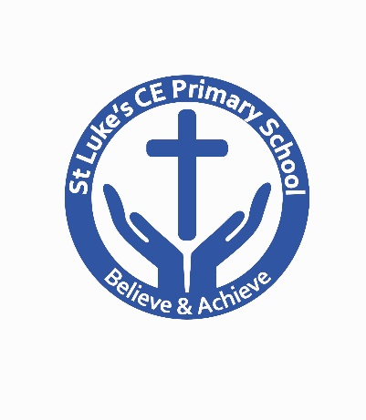
St Luke’s CE Primary School
Queen’s Park Road, Heywood, Lancs, OL10 4XB

Telephone: 01706 369443
Web: www.stlukesce.co.uk
Email: office@stlukesceprimary.co.uk
Head teacher: Mrs K Farrall

23rd May 2018

Dear Parents and Carers,

Changes to Data Protection Law

You may be aware that from May, the rules around data protection are changing. The 'General Data Protection Regulation' (GDPR) will change how we can use your personal data and keep it safe, and will also strengthen your rights over your own data.

The point of this is to make sure sensitive or private information about yourselves and your children stays safe. Whilst it is similar to the current Data Protection Act in many ways, there are a few differences, so we need to make a few changes at the school in order to ensure we remain compliant.

One of these changes is that we have updated our privacy notice. You can find the changes on the St. Luke’s CE Primary School website under “Statutory”.

As part of our work to comply with the GDPR, we are also re-seeking consent for using photographs or videos of your child on our website, internal displays or other school materials. We have enclosed this form, and would appreciate it if you filled this out and returned it to the school office by Wednesday 6th June 2018. The information in this form will be used throughout your child’s time at school. You may withdraw your consent at any time by contacting the school.

If you have any questions about how the GDPR affects you, or how our school is preparing, you can contact either myself or Mrs Thompson in the school office.
Yours faithfully,

Kim Farrall
Head Teacher

