St Luke’s CE Primary
Autumn 1
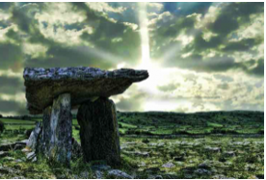

Year 3

Tribal Tales

Discrete Learning subjects -

Main Learning Focus in English:
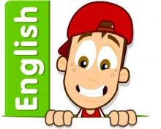
Range: Stone Age Boy. Narrative, Non-fiction texts: Information text
Activities will include:
Speaking and listening.
Participation in class and group discussions Explaining and justifying opinions about texts Learning new drama skills
Reading
Shared Reading – reading an enlarged text with the class Guided Reading – reading with the teacher in small groups Individual & paired reading
Using reading skills to obtain information
Writing
Developing writing for a range of purposes and audiences Improving story writing skills
Planning and structuring different texts
Grammar and Punctuation
Revising the use of capital letters, full stops, commas and exclamation marks Punctuating sentences accurately using speech marks and question marks
Spelling
Words from statutory and personal spelling lists
Proofreading for words on statutory list
Homophones

Handwriting
Revising letter joins formation
Improve skills in joining writing

Main Learning Focus in Mathematics:
Children will learn to:
- Identify, represent and estimate numbers using different representations.

- Find 10 or 100 more or less than a given number

- Recognise the place value of each digit in a three-digit number (hundreds, tens, ones).
- Compare and order numbers up to 1000
- Read and write numbers up to 1000 in numerals and in words.

- Solve number problems and practical problems involving these ideas. Count from 0 in multiples of 4, 8, 50 and 100

