St Luke’s CE Primary
Spring 1

Year 3

Scrumdiddlyumptious!

Discrete Learning subjects -

Main Learning Focus in English:
Text: Charlie and the Chocolate Factory. Narrative, Non-fiction texts: Information text
Activities will include:
Speaking and listening.
Participation in class and group discussions Explaining and justifying opinions about texts Learning new drama skills
Reading
Shared Reading – reading an enlarged text with the class Guided Reading – reading with the teacher in small groups Individual & paired reading
Using reading skills to obtain information
Writing
Developing writing for a range of purposes and audiences Improving story writing skills
Planning and structuring different texts
Grammar and Punctuation
Revising the use of capital letters, full stops, commas and exclamation marks Punctuating sentences accurately using speech marks and question marks
Spelling
Words from statutory and personal spelling lists
Proofreading for words on statutory list
Suffixes and Prefixes

Handwriting
Revising letter joins formation
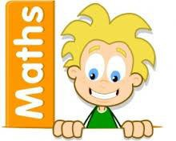
Improve skills in joining writing

Main Learning Focus in Mathematics:

- Comparing statements
- Related calculations
- Multiplying 2-digits by 1-digit using the grid and expanded column method and compact method
- Dividing 2-digits by 1-digit
- Scaling using times tables knowledge

Continual times table practice

