St Luke’s CE Primary
Spring 2
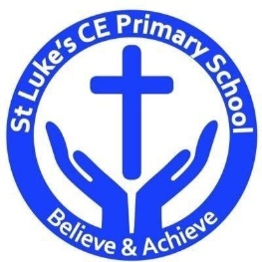

Year 2

Why did the Titanic sink?

Could you be the next Lightning McQueen?

St Luke’s CE Primary – Contextual Learning Unit on the
Quality Text: The Leopard’s drum and Non-fiction books about the Titanic
Lead Subject Focus: History Subsidiary Learning Focus: Science and Design and Technology
Discrete Learning Areas:
English Music Geography
Mathematics French PSHE
Computing Religious Education Physical Education

Design & Technology
Make a model of the Titanic (Homework)
Historical Contextual Learning
- What was the Titanic and why do we talk about it today?
- What can you find out about some of the people on board?
- How can you recreate the events of the sinking of the Titanic?
- How can you recreate a model of the Titanic?
- What was different about being a first or a third class passenger?

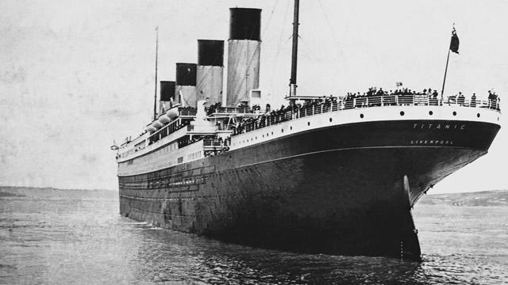

Science
- Looking at floating and sinking.
- Melting an ice cube investigation.

Discrete Learning Subjects
Main Learning Focus in English:
Range: Narrative text- The Leopard’s drum. Non fiction books based on the Titanic.
Speaking and listening.
Participation in class and group discussions Explaining and justifying opinions about texts Learning new drama skills
Reading
Shared Reading – reading the class book
Guided Reading – reading with the teacher in small groups Individual reading (from the school schemes)
Using reading skills to obtain information
Writing
- Consider what they are going to write before beginning by writing down ideas and/or key words, including new vocabulary.
- Read aloud what they have written with appropriate intonation to make the meaning clear.
- Writing about real events.

Grammar and Punctuation
- Learn how to use expanded noun phrases to describe and specify.
- Learn how to use both familiar and new punctuation correctly including full stops, capital letters, exclamation marks, question marks, commas for lists and apostrophes for contracted forms and the possessive (singular).
Spelling
- Adding ly and en
- Exception words
- Adding ment and ful
Handwriting
- Form lower-case letters of the correct size relative to one another.
- Start using some of the diagonal and horizontal strokes needed to join letters and understand which letters, when adjacent to one another, are best left unjoined.
- Write capital letters and digits of the correct size, orientation and relationship to one another and to lower case letters.

Main Learning Focus in Mathematics:
Children will learn to:
- recognise, find, name and write fractions 1/3, 1/4, 2/4 and 3/4 of a length, shape, set of objects or quantity
- write simple fractions for example, 1/2 of 6 = 3 and recognise the equivalence of 2/4 and 1/2.
- choose and use appropriate standard units to estimate and measure length/height in any direction (m/cm); mass (kg/g); temperature (°C); capacity (litres/ml) to the nearest appropriate unit, using rulers, scales, thermometers and measuring vessels
- compare and order lengths, mass, volume/capacity and record the results using >, < and =
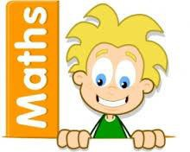

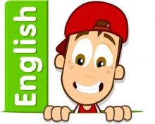

Main Learning Focus in Science:
Could you be the next Lightning McQueen? Floating and sinking, Forces and Movement.
- I can watch closely using equipment.
- I can do tests.
- I can collect and record data to help answer questions.
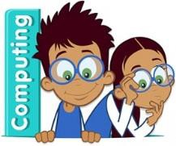
Main Learning Focus in Computing:
Creating pictures:
- I can explain what is meant by impressionist art.
- I can use 2Paint a Picture to create my own art based upon this style.
- I can describe the main features of art that uses repeating patterns.
- I can use 2Paint a Picture to create my own art by repeating patterns in a variety way.
Main Learning Focus in Religious Education:
- When do we cooperate and why?
- Which charities are linked to religions?
- When do these different charities work together?
- When else do people of different religions come together and why?
Main Learning Focus in PSHE:
Getting on and falling out
- To share with others.
- I can work in groups with other children.
- I can listen well to other people when they are talking.
Specialist Taught Subjects:
Main Learning Focus in Physical Education:
Dance:
- understand that dance plays an important part in other cultures.
- Remember and repeat movements, phrases and patterns
- Observe each other dancing and describe what they see
Rugby:
- I can follow simple rules
- I can perform evasion skills as an attacker
- I can perform the role of defending through marking
- I can control and pass a ball from hand to hand
Main Learning Focus in French:
Meet and greet other people

Main learning Focus in Music:
African song:
- use their voices expressively and creatively by singing songs and speaking chants and rhymes.
- listen with concentration and understanding to a range of high-quality live and recorded music.
Easter song for Easter mass.
