St Luke’s CE Primary
Reception
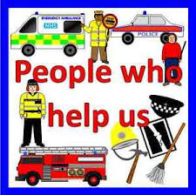

Autumn 2

People Who Help Us/ Christmas

St Luke’s CE Primary – Contextual Learning Unit on People who help us and Christmas
Lead Subject Focus: Understanding the World
Subsidiary Learning Focus: Literacy, Personal, Social and Emotional development and Mathematics

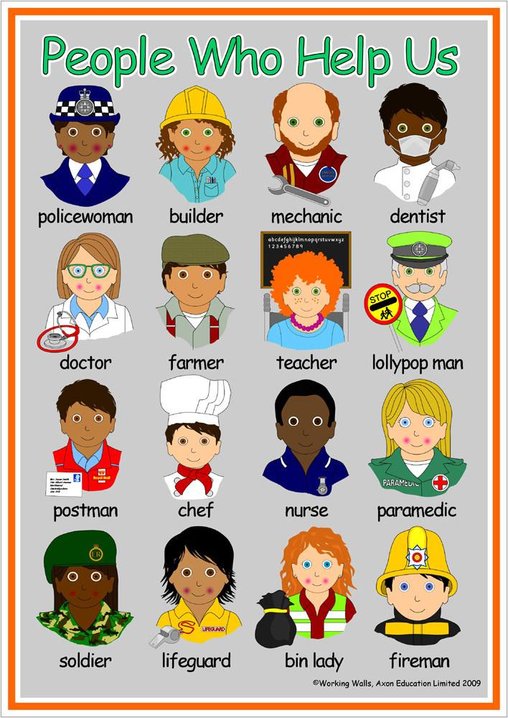
Personal, Social and Emotional Development
- Confident to talk to other children when playing, and will communicate freely about own home and community.
- Understands that own actions affect other people, for example, becomes upset or tries to comfort another child when they realise they have upset them.
- Children talk about how they and others show feelings, talk about their own and others’ behaviour, and its consequences, and know that some behaviour is unacceptable.
- They show sensitivity to others’ needs and feelings, and form positive relationships with adults and other children.
Understanding the World
- Shows interest in different occupations and ways of life. Understand how people help us.
- Knows some of the things that make them unique, and can talk about some of the similarities and differences in relation to friends or family.
- Enjoys joining in with family customs and routines.
- Comments and asks questions about aspects of their familiar world such as the place where they live or the natural world.
- Use a simple program on a computer to create Christmas pictures.

Literacy
- Listens to and joins in with stories and poems, one-to-one and also in small groups.
- Beginning to be aware of the way stories are structured.
- Suggests how the story might end.
- Continues a rhyming string.
- Hears and says the initial sound in words.
- Can segment the sounds in simple words and blend them together and knows which letters represent some of them.
- Can recognise and write their name fluently.
- Gives meaning to marks they make as they draw, write and paint.
- Begins to break the flow of speech into words.
- Hears and says the initial sound in words.
- Can segment the sounds in simple words and blend them.

Communication and Language
- Maintains attention, concentrates and sits quietly during appropriate activity.
- Beginning to understand ‘why’ and ‘how’ questions.
- Uses talk to connect ideas, explain what is happening and anticipate what might happen next, recall and relive past experiences. They listen to stories, accurately anticipating key

Main Learning Focus – Mathematics
- Compares two groups of objects, saying when they have the same number.
- Shows an interest in number problems.
- Separates a group of three or four objects in different ways, beginning to recognise that the total is still the same.
- Counts up to three or four objects by saying one number name for each item.
- Counts actions or objects which cannot be moved.
- Counts objects to 10, and beginning to count beyond 10.
- Selects the correct numeral to represent 1 to 5, then 1 to 10 objects.
- Counts an irregular arrangement of up to ten objects.
- Uses the language of ‘more’ and ‘fewer’ to compare two sets of objects.
- Rote count up to 10 forwards and backwards. Beginning to count up to 20 forwards and backwards.
- Recognise numerals up to 10 and then up to 20.
Main Learning Focus – Physical Development
- Moves freely and with pleasure and confidence in a range of ways, such as slithering, shuffling, rolling, crawling, walking, running, jumping, skipping, sliding and hopping.
- Runs skilfully and negotiates space successfully, adjusting speed or direction to avoid obstacles.
- Can stand momentarily on one foot when shown.
- Draws lines and circles using gross motor movements.
- Uses one-handed tools and equipment, e.g. makes snips in paper with child scissors.
- Shows a preference for a dominant hand.
- They manage their own basic hygiene and personal needs successfully, including dressing and going to the toilet independently.
Main Learning Focus – Expressive Arts and Design
- Enjoys joining in with dancing and ring games.
- Sings a few familiar songs.
- Beginning to move rhythmically.
- Imitates movement in response to music.
- Taps out simple repeated rhythms.
- Explores and learns how sounds can be changed.
- Explores colour and how colours can be changed.
- Begins to build a repertoire of songs and dances.
- Explores the different sounds of instruments.
- Explores what happens when they mix colours. Children sing songs, make music and dance.

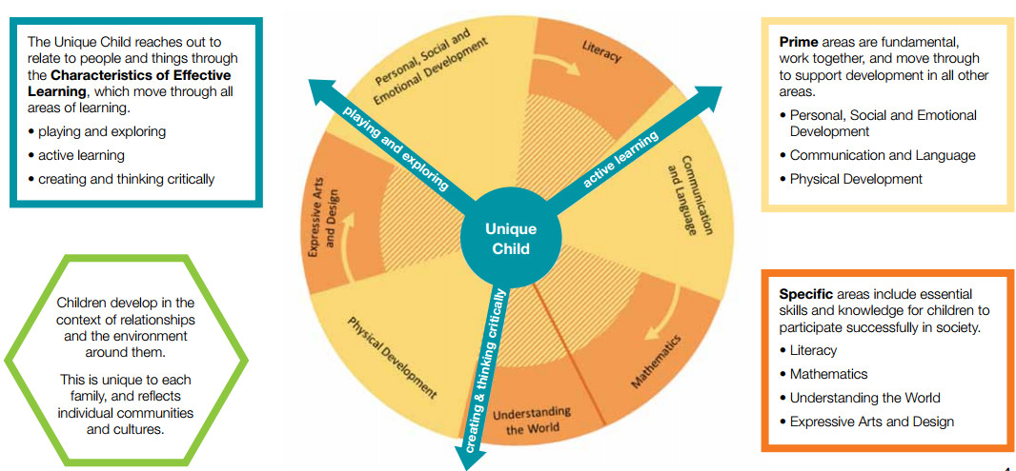

Homework
- Your child will bring home a reading book to share with you at home, please sign the reading record when you have read with your child. They should read a minimum of 4 times a week.
- Please practice key words (orange book) and the letter sounds 4 times a week.
- Please practice the targets in the maths passports with your child.
Early Years- Overarching Principles
every child is a unique child, who is constantly learning and can be resilient, capable, confident and self-assured;
• children learn to be strong and independent through positive relationships;
• children learn and develop well in enabling environments, in which their experiences respond to their individual needs and there is a strong partnership between practitioners and parents and/or carers; and
• children develop and learn in different ways and at different rates. The framework covers the education and care of all children in early years’ provision, including children with special educational needs and disabilities.

