St Luke’s CE Primary
Spring 1
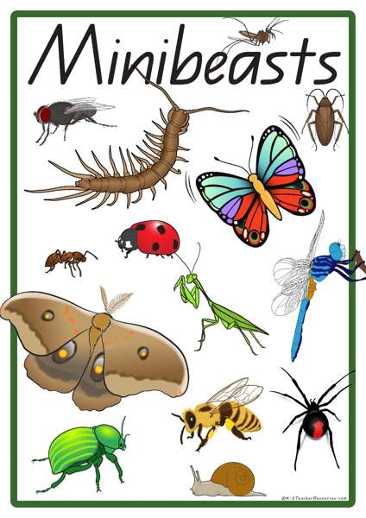

Year 2

Wriggle and crawl

Discrete Learning Subjects
Main Learning Focus in English:
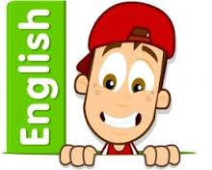
Range: Non-Fiction text- Non chronological report
Speaking and listening.
Participation in class and group discussions Explaining and justifying opinions about texts
Preforming poetry
Reading
Shared Reading – reading the class book
Guided Reading – reading with the teacher in small groups Individual reading (from the school schemes)
Using reading skills to obtain information
Writing
- Write a long piece of text about a real event in one go.
- Write sentences about things they have done and that others have.
- To write and perform poetry.
Grammar and Punctuation
- Use co-ordination (using or, and, but) and some subordination (using when, if, that, because) to join clauses.
- Use the progressive form of verbs in the present and past tense to make actions in progress e.g. she is drumming, he was shouting.
- Use present and past tense mostly correctly.
Spelling
- Adding s or es
- Er, est
- Homophones
- Phase 5 recap
Handwriting
- Form lower-case letters of the correct size relative to one another using tails and flicks.
- Write capital letters and digits of the correct size, orientation and relationship to one another and to lower case letters.

Main Learning Focus in Mathematics:
Children will learn to:
- Recall and use multiplication and division facts for the 2, 5 and 10 times tables, including recognising odd and even numbers
- Calculate mathematical statements for multiplication and division within the multiplication tables and write them using the multiplication (×), division (÷) and equals (=) signs.
- Solve problems involving multiplication and division, using materials, arrays, repeated addition, mental methods and multiplication and division facts, including problems in contexts.
- Show that the multiplication of two numbers can be done in any order (commutative) and division of one number by another cannot.
- Interpret and construct simple pictograms, tally charts, block diagrams and simple tables.
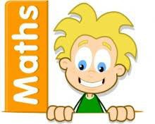
- Ask and answer simple questions by counting the number of objects in each category and sorting the categories by quantity.
- Recap addition and subtraction using column method.
- Begin 2D and 3D shapes.

