St Luke’s CE Primary
Reception
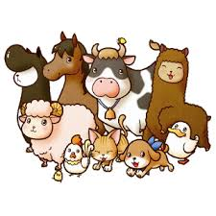
Spring 1

Animals

St Luke’s CE Primary – Contextual Learning Unit on People who help us and Christmas
Lead Subject Focus: Understanding the World
Subsidiary Learning Focus: Literacy, Mathematics and Expressive Arts and Design

Understanding the World
- To make observations about animals.
- Knows some of the things that make themselves and animals unique, and can talk about some of the similarities and differences.
- Enjoys joining in with family customs and routines.
- Comments and asks questions about aspects of their familiar world such as the place where they live or the natural world.
- Use a simple program on a computer to create animal pictures and to create a farm.
- To enjoy celebrating Chinese New Year.
- To compare habitats and then design and make their own animal habitat.
Mathematics
- To recognise numbers up to 10 and then 20.
- To order numbers up to 10 and then 20.
- To say one more and one less than a given number.
- To compare different animals size and length.
- To add two single digit numbers together (using objects to begin with and then numerals).
- To subtract two single digit numbers together (using objects to begin with and then numerals).
- To count forwards and backwards up to 20.
- Use the language of more and fewer.

Expressive Arts and Design
- To explore the different sounds of musical instruments.
- To sing animal songs and nursery rhymes. Then to adapt these to different animals.
- To design and make animal homes.
- To select appropriate colours, equipment and materials for a task.
- To represent their own ideas and thoughts through role play, music and art.
- To design their own animal.
- To include a storyline into their role play.
Literacy
- Being aware of the way stories are structured and suggesting how a story might end.
- Continues a rhyming string.
- Can segment the sounds in simple words and blend them together.
- Can write their name fluently.
- Gives meaning to marks they make as they draw, write and paint.
- Begins to break the flow of speech into words.
- Can segment the sounds in simple words and blend them.
- Can write CVC words and begin to write captions and phrases.
- To begin to read and write simple sentences.
- To retell familiar stories.
- To begin to make up their own animal stories and tell retell it to a friend.

Main Learning Focus – Communication and Language
- Maintains attention, concentrates and sits quietly during appropriate activity.
• Two-channelled attention – can listen and do for short span.
- Children listen attentively in a range of situations.
- They listen to stories, accurately anticipating key events and respond to what they hear with relevant comments, questions or actions.
- Responds to instructions involving a two-part sequence. Understands humour, e.g. nonsense rhymes, jokes.
- Able to follow a story without pictures or props.
- Listens and responds to ideas expressed by others in conversation or discussion.
- Uses language to imagine and recreate roles and experiences in play situations.
- Links statements and sticks to a main theme or intention.
- Uses talk to organise, sequence and clarify thinking, ideas, feelings and events.
- Uses a storyline or narrative into their play.
Main Learning Focus – Physical Development
- Moves freely and with pleasure and confidence in a range of ways, such as slithering, shuffling, rolling, crawling, walking, running, jumping, skipping, sliding and hopping.
- Runs skilfully and negotiates space successfully, adjusting speed or direction to avoid obstacles.
- Jumps off an object and lands appropriately.
- Travels with confidence and skill around, under, over and through balancing and climbing equipment.
- Begins to form recognisable letters.
- Uses a pencil and holds it effectively to form recognisable letters, most of which are correctly formed.
Main Learning Focus – Personal, Social and Emotional Development.
- Children play co-operatively, taking turns with others.
- They take account of one another’s ideas about how to organise their activity.
- Children are confident to try new activities, and say why they like some activities more than others.
- They are confident to speak in a familiar group, will talk about their ideas, and will choose the resources they need for their chosen activities.
- They work as part of a group or class, and understand and follow the rules.
- They adjust their behaviour to different situations, and take changes of routine in their stride.

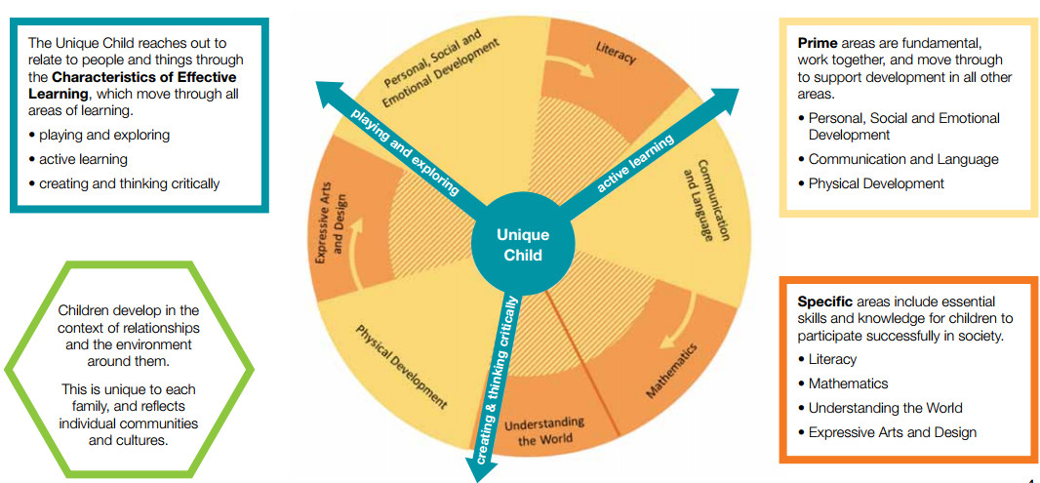

Homework
- Your child will bring home a reading book to share with you at home, please sign the reading record when you have read with your child. They should read a minimum of 4 times a week.
- Please practice key words (orange book) and the letter sounds 4 times a week.
- Please practice the targets in the maths passports with your child.
Early Years- Overarching Principles
every child is a unique child, who is constantly learning and can be resilient, capable, confident and self-assured;
• children learn to be strong and independent through positive relationships;
• children learn and develop well in enabling environments, in which their experiences respond to their individual needs and there is a strong partnership between practitioners and parents and/or carers; and
• children develop and learn in different ways and at different rates. The framework covers the education and care of all children in early years’ provision, including children with special educational needs and disabilities.

