St Luke’s CE Primary
Year 4
Spring 1
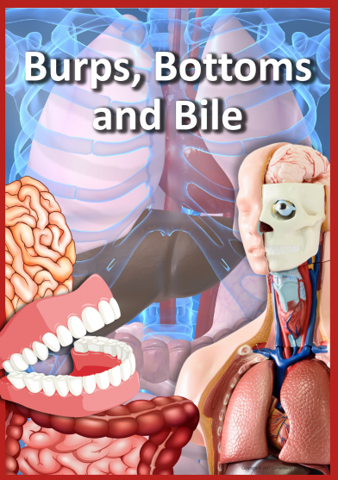

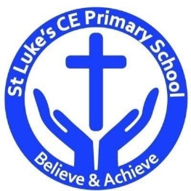

Discrete Learning Subjects
Main Learning Focus in English:

Fiction: The Incredible Book Eating Boy by Oliver Jeffers
Non-fiction: Non-chronological reports and Newspaper report.

Speaking and listening.
Participation in class and group discussions Explaining and justifying opinions about texts Learning new drama skills
Reading
Shared Reading – reading text with the class
Guided Reading – reading with the teacher in small groups Individual & paired reading
Using reading skills to obtain information
Writing
Using Fantasics to develop narrative recount writing -Picture book
Writing newspaper report
Planning and structuring different texts
Answering big questions
Illustrations to tell a story
Grammar and Punctuation
Revising the use of capital letters, full stops, commas and exclamation marks Ensuring grammatical agreement
Spelling
Words from statutory and personal spelling lists
Proofreading for words on statutory list
Handwriting
Revising letter joins formation
Improve skills in joining writing
Main Learning Focus in Mathematics:

Children will learn to:
11 and 12 times-table
Multiply 3 numbers
Factor pairs
Efficient multiplication
Written methods
Multiply 2-digits by 1-digit
Multiply 3-digits by 1-digit
Divide 2-digits by 1-digit (1)
Divide 2-digits by 1-digit (2)
Correspondence problems
What is area?
Counting squares
Making shapes
Comparing area
