St Luke’s CE Primary
Autumn 2
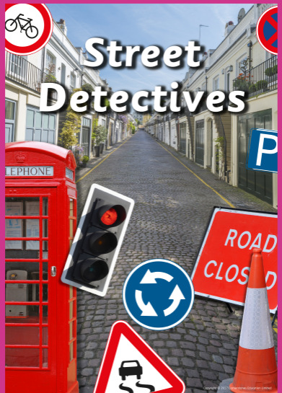

Year 2

Discrete Learning Subjects
Main Learning Focus in English:
Range: Fiction ‘On the way home’ and ‘Building boy’
Speaking and listening.
Participation in class and group discussions Explaining and justifying opinions about texts
I can listen, talk to and have an opinion on a wide range of stories.
Reading
Shared Reading – reading the class books
Guided Reading – reading with the teacher in small groups Individual reading (from the school schemes)
Teachers 4 teachers comprehension
Writing
I can spell some words words which have been shortend
I can write the correct spelling and punctuation in simple sentences I hear my teacher say.
I can plan my writing by writing down my ideas or talking about them.
I can use description in my writing eg the blue butterfly, plain flour, the man on the moon.
I can tell if a sentence is a question, command, exclamation or statement.
Grammar and Punctuation
- Use co-ordination (using or, and, but) and some subordination (using when, if, that, because) to join clauses.
- Use the progressive form of verbs in the present and past tense to make actions in progress e.g. she is drumming, he was shouting.
- Use present and past tense mostly correctly.
Spelling
- Apostrophe’s
- Adding suffixes
Handwriting
- Form lower-case letters of the correct size relative to one another using tails and flicks.
- Write capital letters and digits of the correct size, orientation and relationship to one another and to lower case letters.

Main Learning Focus in Mathematics:
Children will learn to:

- Add a 2-digit and 1-digit number – crossing ten
- Subtract a 1-digit number from a 2-digit number – crossing ten
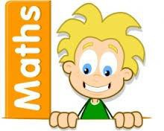
- Add two 2-digit numbers – crossing ten
- Subtract a 2-digit number from a 2-digit number – crossing ten
- Know my bonds to 100
- Add three 1-digit numbers
- Count money – pence and pounds/notes and coins.
- Select money
- Compare money
- Find totals, difference and change.
Solve 2 Two-step money problems

