St Luke’s CE Primary
Spring 1
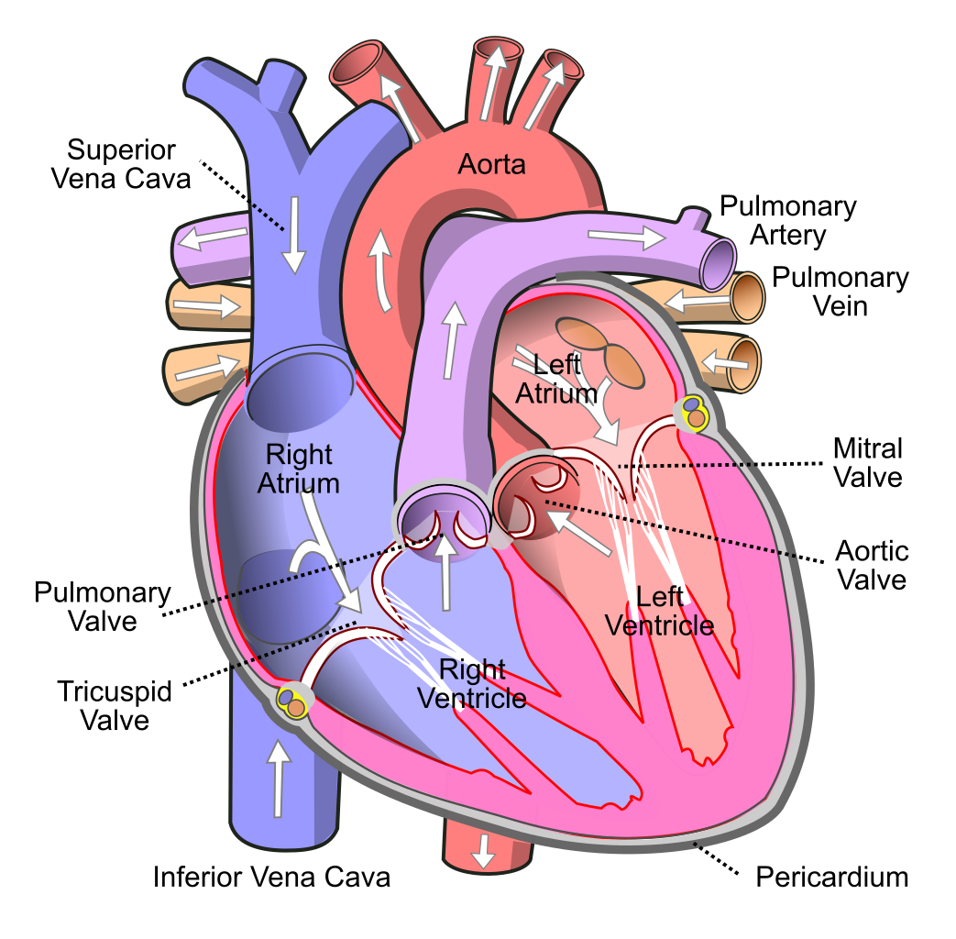

Blood heart

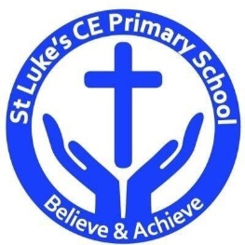

Science
- Record data and results of increasing complexity using diagrams, charts and graphs.
- Record and present findings from enquiries, including conclusions.
- Take measurements using a range of scientific equipment.
- Identify scientific evidence which has been used to support ideas.
Scientific Contextual Learning
- Identify and name the main parts of the human circulatory system, and describe functions of the heart, blood and blood vessels.
- Recognise the impact of diet, exercise, drugs, and lifestyle on the way their bodies function.
- Describe the ways in which nutrients and water are transported within animals, including humans.
St Luke’s CE Primary – Contextual Learning Unit Circulatory System
Lead Subject Focus: Science Subsidiary Learning Focus: D&T
Discrete Learning Areas:
English Music
Mathematics French PSHE
Computing Religious Education Physical Education

Design & Technology
- Select from a range of tools to perform practical tasks.
- Prepare and cook a range of dishes using a range of cooking techniques.
- Investigate and analyse a range of existing products.
- Build structures.

Discrete Learning Subjects
Main Learning Focus in English:
Range: Ghost story narratives; alternate endings and openings; mystery. Activities will include:
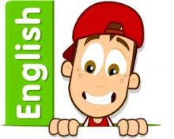
Speaking and listening.
Participation in class and group discussions Explaining and justifying opinions about texts Discussing information inferred from a text
Reading
Shared Reading – reading The Watertower; The Graveyard Book.
Guided Reading – reading with the teacher in small groups Individual reading – follow-up tasks from guided reading sessions
Focus on using information from the text to build written responses
Writing
Developing writing for a range of purposes and audiences
Create atmosphere and mood.
Describe characters and settings.
Structuring different texts
Grammar and Punctuation
Grammatical structures used in more formal writing.
Punctuating sentences accurately with the full range of punctuation taught at KS2.
Sentence lengths vary for effect.
Spelling
Developing a range of spelling strategies Using words with spelling patterns from Y5&6 list
Using knowledge of prefixes and suffixes to spell words
Handwriting
Writing legibly with speed and fluency
Main Learning Focus in Mathematics:
Children will learn to:
- Compare and order fractions, including fractions > 1
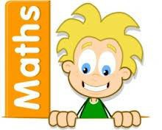
- express missing number problems algebraically
- solve problems involving the calculation and conversion of
- units of measure, using decimal notation to three decimal
- places where appropriate
- use, read, write and convert between standard units,
- converting measurements of length, mass, volume and time
- from a smaller unit of measure to a larger unit, and vice
- versa, using decimal notation to up to three decimal places
- convert between miles and kilometres
- recognise that shapes with the same areas can have
- different perimeters and vice versa
- recognise that shapes with the same areas can have
- different perimeters and vice versa
- calculate the area of parallelograms and triangles
- calculate, estimate and compare volume of cubes and
- cuboids using standard units, including centimetre cubed
- (cm3
- ) and cubic metres (m3
- ) and extending to other units,

Main Learning Focus in Science: Circulatory system
- Identify and name the main parts of the human circulatory system, and describe functions of the heart, blood and blood vessels.
- Recognise the impact of diet, exercise, drugs, and lifestyle on the way their bodies function.
- Describe the ways in which nutrients and water are transported within animals, including humans.
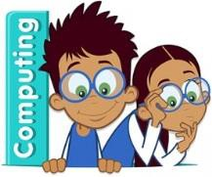
Main Learning Focus in Computing: We are programmers use a range of software to accomplish given goals.
Use search technologies effectively.
Understand computer networks including the internet.
Main Learning Focus in Religious Education: religion through art
- What is religious art?
- What stories do religious art tell?
- Why is religious art important?
Main Learning Focus in PSHE:
Begin to develop confidence and responsibility
Preparing to play an active role as citizens
Discuss a healthy, safe lifestyle

Specialist Taught Subjects:
Main Learning Focus in Physical Education:
Work will include individual, group and paired activities Leading simple invasion, net and striking and fielding games
Developing a range of throwing and catching techniques for basketball Keeping score, developing rules and simple tactics within games
Recognising good performance and using this to improve skills
Record and discuss how our bodies feel during and after exercise and the benefits
Main Learning Focus in French:
Greetings and classroom vocabulary
Be able to talk about ourselves
Everyday objects and hobbies
Write full sentences
Main learning Focus in Music:
Listening to, making, exploring and discussing sounds Recognising different sources of sounds

