St Luke’s CE Primary
Spring 2

Year 3

Gods and Mortals

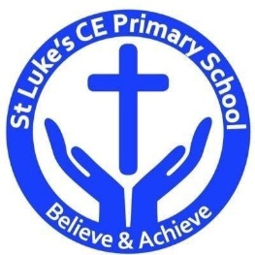

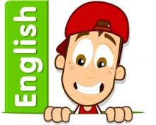

Discrete Learning subjects -

Main Learning Focus in English:
Range: Greek Myths and Legends. Narrative, Non-fiction texts: Information text
Activities will include:
Speaking and listening.
Participation in class and group discussions Explaining and justifying opinions about texts Learning new drama skills
Reading
Shared Reading – reading an enlarged text with the class Guided Reading – reading with the teacher in small groups Individual & paired reading
Using reading skills to obtain information
Writing
Developing writing for a range of purposes and audiences Improving story writing skills
Planning and structuring different texts
Grammar and Punctuation
Revising the use of capital letters, full stops, commas and exclamation marks Punctuating sentences accurately using speech marks and question marks
Spelling
Words from statutory and personal spelling lists
Proofreading for words on statutory list
Homophones

Handwriting
Revising letter joins formation

Main Learning Focus in Mathematics:

Children will learn to:

- Measure length and convert lengths – m & cm, mm & cm
- Compare lengths
- Add lengths
- Subtract lengths
- Measure perimeter
- Calculate perimeter
- Understand Unit and non-unit fractions
- Count in tenths
- Understand Tenths as decimals
- Find Fractions of a number line
- Find fractions of a set of object

