St Luke’s CE Primary
Reception

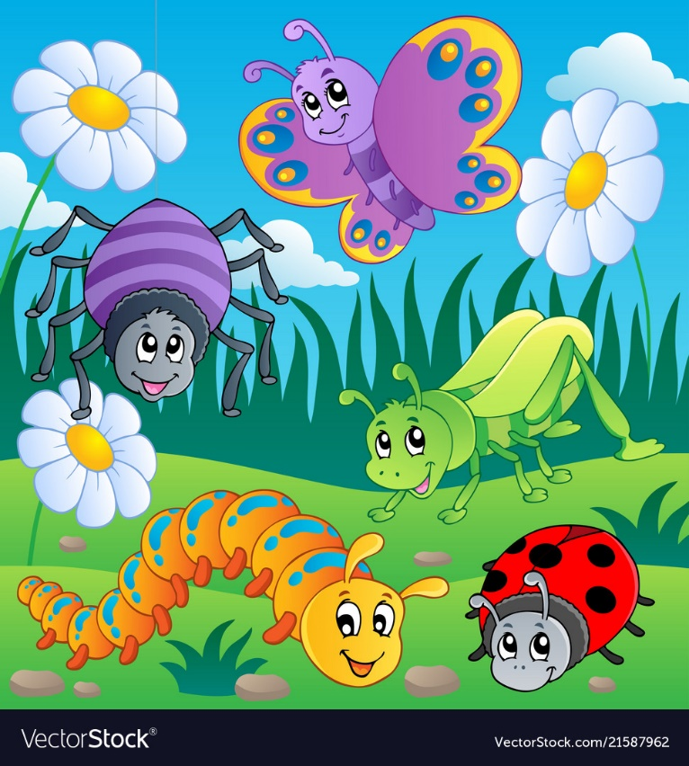
Spring Two

Animals and Easter

St Luke’s CE Primary – Contextual Learning Unit on Animals and Easter
Lead Subject Focus: Literacy
Subsidiary Learning Focus: Communication and Language, Expressive arts and design, Personal, social and emotional development.
Communication and language Contextual Learning
- Links statements and sticks to a main theme or intention.
- Uses talk to organise, sequence, and clarify thinking, ideas, feelings and events.
- Uses language to imagine and create roles.
- Children use past, present and future tense accurately.
- Children can answer how and why questions.
- Children listen attentively in a range of situations.
- Maintains attention and concentration during activities.
- Able to follow a story without pictures.
- Listens and responds to ideas expressed by others in conversation or discussion.

Expressive arts and design
- Experiments to create different textures.
- Understands that different media can be combined to create new effects.
- Manipulates materials to achieve a planned effect.
- Constructs with a purpose in mind, using a variety of resources.
- Uses simple tools and techniques competently and appropriately.
- Selects appropriate resources and adapts work where necessary.
- Chooses particular colours to use for a purpose.

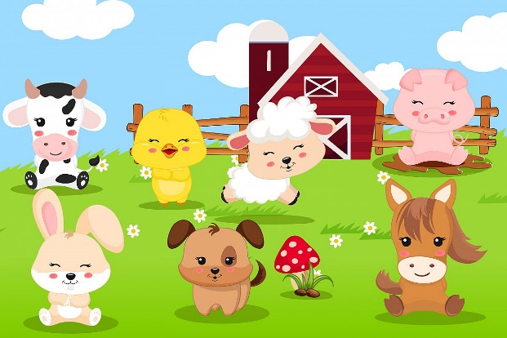

Personal, social and emotional developent
- Confident to speak to others about own needs, wants, interests and opinions.
- Can describe self in positive terms and talk about abilities.
- Children play cooperatively, taking turn with others.
- Children are confident to try new activities.
- Children are confident to speak in a familiar group.
- Children initiate conversation and takes account of what other children say.

Literacy
• Begins to fluently read words and simple sentences.
• Enjoys an increasing range of books.
- Children demonstrate understanding when talking with others about what they have read.
• Links sounds to letters, naming and sounding the letters of the alphabet.
• Writes labels and captions for a purpose.
• Children write simple sentences which can be read by themselves and others. Some words are spelt correctly and others are phonetically plausible.

Main Learning Focus – Physical development
• Holds pencil near point between first two fingers and thumb and uses it with good control.
• Eats a healthy range of foodstuffs and understands need for variety in food.
• Shows some understanding that good practices with regard to exercise, eating, sleeping and hygiene can contribute to good health.
• Practices some appropriate safety measures without direct supervision.
• Children show good control and co-ordination in large and small movements.
• They move confidently in a range of ways, safely negotiating space.

Main Learning Focus – Mathematics
• Begins to identify own mathematical problems based on own interests and fascinations.
• Orders two or three items by weight and height.
• Children use everyday language to talk about size, weight, capacity, position and distance to compare quantities and objects to solve problems.
• Children count reliably with numbers from 1-20, place them in order saying which number is one more and one less than a given number.
• Using quantities and objects, they add and subtract two single digit numbers and count on or back to find the answer.

Main Learning Focus – Understanding the world
- Looks closely at similarities, differences, patterns and change.
- They know about similarities and differences between themselves and others and among families, communities and traditions.
- Children recognise that a range of technology is used in places such as homes and schools.
- They select and use technology for particular purposes.
- Children know that other children don’t always enjoy the same things as they do and are sensitive to this.
- Know the Easter story.
- Learn about Lent.

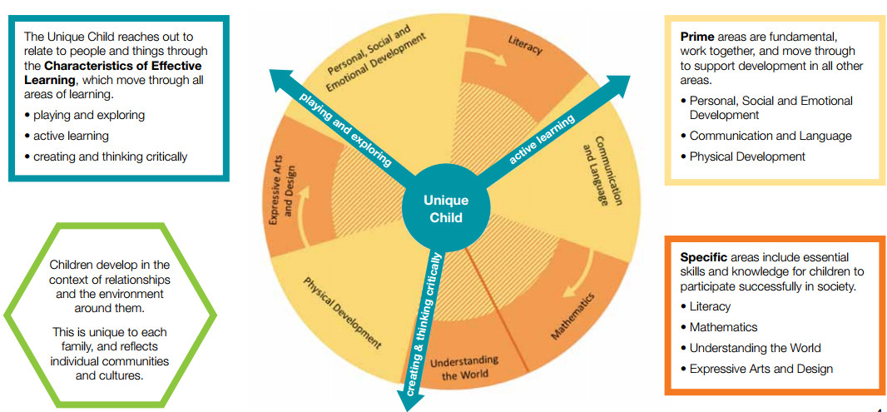

Homework
• Your child will bring home a reading book to share with you at home, please sign the reading record when you have read with your child. They should read a minimum of 4 times a week.
• Please practice key words (orange book).
• Please practice your child’s math’s passport targets with them at home.
Early Years- Overarching Principles
every child is a unique child, who is constantly learning and can be resilient, capable, confident and self-assured;
• children learn to be strong and independent through positive relationships;
• children learn and develop well in enabling environments, in which their experiences respond to their individual needs and there is a strong partnership between practitioners and parents and/or carers; and
• children develop and learn in different ways and at different rates. The framework covers the education and care of all children in early years’ provision, including children with special educational needs and disabilities.

