St Luke’s CE Primary
Year 4
Autumn 2
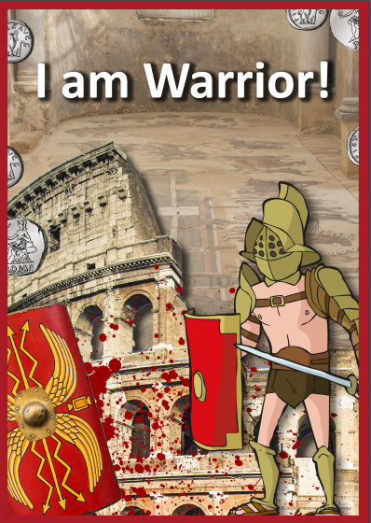
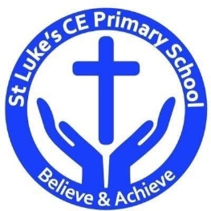
Discrete Learning Subjects
Main Learning Focus in English:
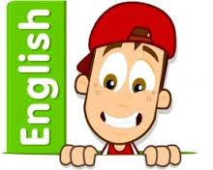
Fiction: The Escape from Pompeii (Historical recount)
Non-fiction: Newspaper report

Speaking and listening.
Participation in class and group discussions Explaining and justifying opinions about texts Learning new drama skills
Reading
Shared Reading – reading text with the class
Guided Reading – reading with the teacher in small groups Individual & paired reading
Using reading skills
obtain information
Writing
Using Fantasics to develop narrative recount writing
Writing newspaper report
Planning and structuring different texts
Answering big questions
Illustrations to tell a story
Grammar and Punctuation
Revising the use of capital letters, full stops, commas and exclamation marks Ensuring grammatical agreement
Spelling
Words from statutory and personal spelling lists
Proofreading for words on statutory list
Handwriting
Revising letter joins formation
Improve skills in joining writing
Main Learning Focus in Mathematics:

In Measurement Children will learn about:  - Kilometres  - Perimeter on a grid  - Perimeter of a rectangle  - Perimeter of rectilinear shape | In multiplication and division children will learn about:  - Multiply by 10  - Multiply by 100  - Divide by 10  - Divide by 100  - Multiply by 1 and 0  - Divide by 1  - Multiply and divide by 6  - 6 times-table and division facts Multiply and divide by 9  - 9 times-table and division facts Multiply and divide by 7  - 7 times-table and division fact

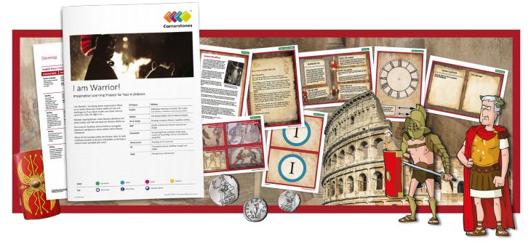

We are brave, powerful warriors, and we will meet in battle!
This half term, we’ll divide into two warring groups: the Celts and the Romans. In our battle games, who will be victorious? We’ll research Celtic and Roman warriors and write soliloquies as soldiers. Using different source materials we’ll investigate the Roman Empire and read Roman numerals. After designing and making shields, we’ll test them in battle and practise our attacking and defending skills. The Celtic warrior queen, Boudicca, will inspire us to create stories, models and artwork. We’ll write plays about gladiators and a menu for wealthy Romans. Using maps, globes and information books, we’ll compare Britain (the home of the Celts) and Rome (the home of the Romans). At the end of the ILP, we’ll reflect on what the Romans did for us. We’ll become archaeologists, examining and sorting artefacts. You’ll receive an invitation to our art gallery where we’ll give guided tours to explain what we have learnt.
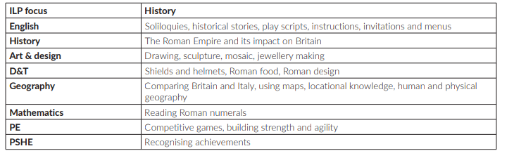

Help your child prepare for their project
The Romans changed the course of England’s history. Why not visit a museum together or look at Roman artefacts online to see what you can learn about the Romans? You could also look at holiday brochures and online information to find out about modern day Rome. Which tourist attractions would you like to visit? Alternatively, you could work together to make a model of a Roman villa using recycled materials.

