St Luke’s CE Primary
Spring 2
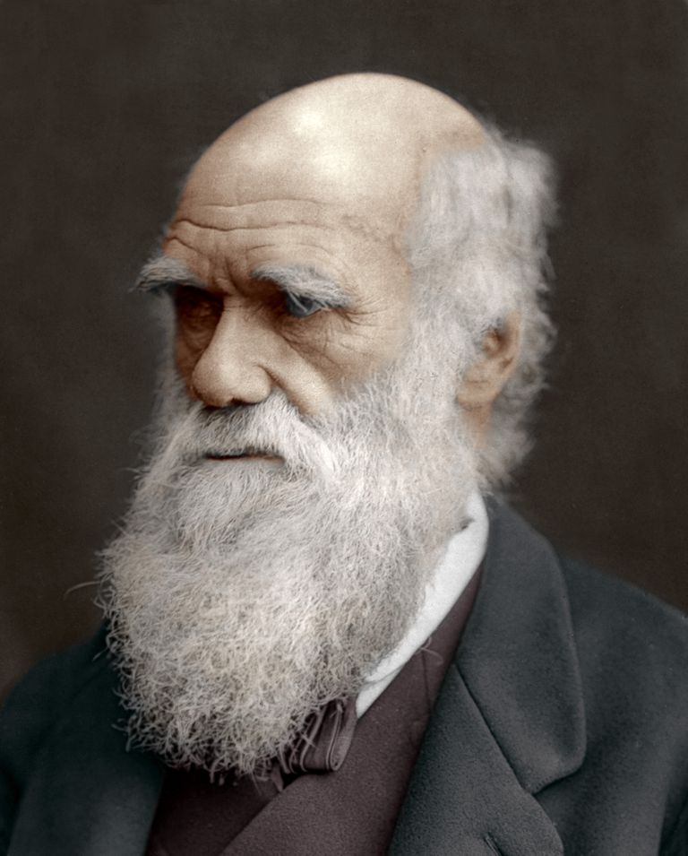

Darwin’s Delights

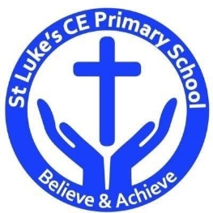

Science
- Record data and results of increasing complexity using diagrams, charts and graphs.
- Record and present findings from enquiries, including conclusions.
- Take measurements using a range of scientific equipment.
- Identify scientific evidence which has been used to support ideas.
- Use test results to make further predictions.
- Plan different types of enquiries.
Scientific Contextual Learning
- Identify how plants and animals are adapted to suit their environment.
- Recognise that living things have changed over time and that fossils provide information about living things.
- Recognise that living things produce offspring of the same kind, but with some differences due to inheritance from parents.

St Luke’s CE Primary – Contextual Learning Unit Evolution
Lead Subject Focus: Science Subsidiary Learning Focus: Geography
Discrete Learning Areas:
English Music
Mathematics French PSHE
Computing Religious Education Physical Education

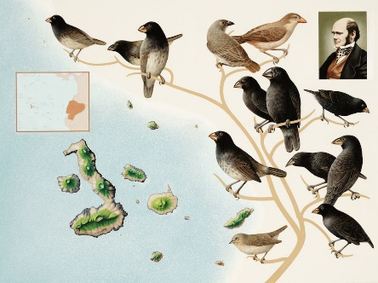

Geography
- Use maps and globes to locate areas and regions studied.
- Understand geographical similarities and differences between the UK and a specific region studied.

Art and Design
- Create sketch books to record observations.
- Improve mastery of art and design.

Discrete Learning Subjects
Main Learning Focus in English:
Range: Ghost story narratives; alternate endings and openings; mystery. Activities will include:
Speaking and listening.
Participation in class and group discussions Explaining and justifying opinions about texts Discussing information inferred from a text
Reading
Shared Reading – reading The Island; The Arrival.
Guided Reading – reading with the teacher in small groups Individual reading – follow-up tasks from guided reading sessions
Focus on using information from the text to build written responses
Writing
Developing writing for a range of purposes and audiences
Create atmosphere and mood.
Describe characters and settings.
Structuring different non-fiction texts: information and biographies.
Grammar and Punctuation
Grammatical structures used in more formal writing.
Punctuating sentences accurately with the full range of punctuation taught at KS2.
Sentence lengths vary for effect.

Spelling
Developing a range of spelling strategies Using words with spelling patterns from Y5&6 list
Using knowledge of prefixes and suffixes to spell words
Handwriting
Writing legibly with speed and fluency
Main Learning Focus in Mathematics:
Children will learn to:
- Compare and order fractions, including fractions > 1
- express missing number problems algebraically
- draw 2-D shapes using given dimensions and angles
- recognise, describe and build simple 3-D shapes, including
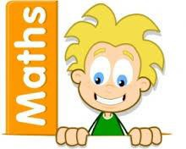
- making nets
- compare and classify geometric shapes based on their
- properties and sizes and find unknown angles in any
- triangles, quadrilaterals, and regular polygons
- illustrate and name parts of circles, including radius,
- diameter and circumference and know that the diameter is
- twice the radius
- recognise angles where they meet at a point, are on a
- straight line, or are vertically opposite, and find missing angles
- describe positions on the full coordinates grid (all four quadrants) draw and translate simple shapes on the coordinates plane, and reflect
- them in the axes
- interpret and construct pie charts and line graphs and use these to solve problems calculate and interpret the mean as an average

Main Learning Focus in Science: Circulatory system
- Identify how plants and animals are adapted to suit their environment.
- Recognise that living things have changed over time and that fossils provide information about living things.
- Recognise that living things produce offspring of the same kind, but with some differences due to inheritance from parents.
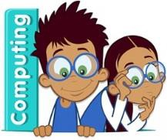
Main Learning Focus in Computing: We are programmers use a range of software to accomplish given goals.
Use search technologies effectively.
Understand computer networks including the internet.
Main Learning Focus in Religious Education: religion through art
- What is religious art?
- What stories do religious art tell?
- Why is religious art important?
Main Learning Focus in PSHE:
Begin to develop confidence and responsibility
Preparing to play an active role as citizens
Discuss a healthy, safe lifestyle

Specialist Taught Subjects:
Main Learning Focus in Physical Education:
Work will include individual, group and paired activities Leading simple invasion, net and striking and fielding games
Developing a range of throwing and catching techniques for basketball Keeping score, developing rules and simple tactics within games
Recognising good performance and using this to improve skills
Record and discuss how our bodies feel during and after exercise and the benefits
Main Learning Focus in French:
Greetings and classroom vocabulary
Be able to talk about ourselves
Everyday objects and hobbies
Write full sentences
Main learning Focus in Music:
Listening to, making, exploring and discussing sounds Recognising different sources of sounds

