St Luke’s CE Primary
Spring 2
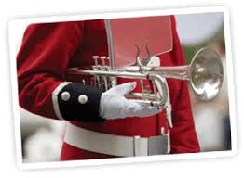

Year 2

Beat, band, boogie

Discrete Learning Subjects
Main Learning Focus in English:
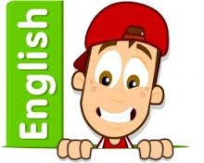
Range: Fiction – The leopard’s Drum. Poetry and nursery rhymes
Speaking and listening.
Participation in class and group discussions Explaining and justifying opinions about texts
Preforming poetry
Reading
Shared Reading – reading the class book
Guided Reading – reading with the teacher in small groups Individual reading (from the school schemes)
Using reading skills to obtain information
Reading comprehension
Writing
- Write a long piece of text about a real event in one go.
- Write sentences about things they have done and that others have.
Grammar and Punctuation
- Use co-ordination (using or, and, but) and some subordination (using when, if, that, because) to join clauses.
- Use the progressive form of verbs in the present and past tense to make actions in progress e.g. she is drumming, he was shouting.
- Use present and past tense mostly correctly.
Spelling
- Apostrophes for possession.
- Adding suffix Phase 6 phonics.
Handwriting
- Form lower-case letters of the correct size relative to one another using tails and flicks.
- Write capital letters and digits of the correct size, orientation and relationship to one another and to lower case letters.

Main Learning Focus in Mathematics:
Working through our passports and practicing on Times table Rockstars.
- Make equaparts
- Recognise a half
- Find a half
- Recognise a quarter
- Find a quarter
- Recognise a third
- Find a third
- Unit fractions
- Non-unit fractions
- Equivalence of 1/2 and 2/4
- Find three quarters
- Count in fractions

