St Luke’s CE Primary
Spring 2

Year 1

Moon Zoom
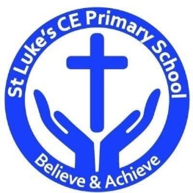
Discrete Learning Subjects
Main Learning Focus in English:
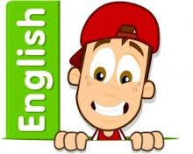
Range: The Three Little Pigs. Narrative. Activities will include:
Speaking and listening.
Participation in class and group discussions Explaining and justifying opinions about texts Learning new drama skills
Taking on the role of a character–hot seating
Reading
Shared Reading – reading an enlarged text with the class Guided Reading – reading with the teacher in small groups
Writing
Planning and structuring a narrative text
Improving story writing skills
Instructions
Grammar and Punctuation
Revising the use of capital letters, full stops and finger spaces
Introducing commas
Using inverted commas
Understanding how to write a 2A sentence
Understanding what a verb is
Ensuring their sentences make sense by checking
Using the conjunction and
Spelling
Developing a range of spelling strategies Using sounds from Phase 2 to 5
Spelling some/most common irregular words
Handwriting
Revising basic letter formation
Looking at tails and flicks
Main Learning Focus in Mathematics:

Children will learn to:

- Count to 50 forwards and backwards, beginning with 0 or 1, or from any number.
- Count, read and write numbers to 50 in numerals.
- Given a number, identify one more or one less.
- Identify and represent numbers using objects and pictorial representations including the number line, and use the language of: equal to, more than, less than (fewer), most, least.
- Count in multiples of twos, fives and tens.
- Measure and begin to record lengths and heights.
- Compare, describe and solve

- practical problems for: lengths and heights (for example, long/short, longer/shorter, tall/short, double/half)

