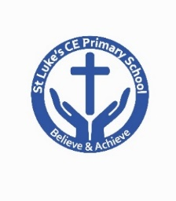
Newsletter 28th March 2019
https://stlukesceprimary.blog-pages.co.uk

St Luke’s CE Primary School

Attendance | 18-22nd March
Reception B/bells | 93.6%
Year 1 Willows | 94.1%
Year 1 Oaks | 95.7%
Year 2 Elm | 97.7%
Year 2 Ash | 96.2%
Year 3 Cedar | 95.5%
Year 3 Birch | 99.3%
Year 4 Maple | 99.0%
Year 5 Pine | 96.0%
Year 6 Sycamore | 90.4%

Easter Hamper
Tickets are still on sale for our Easter Hamper priced at 50p each and will be drawn on Thursday 4th April.
Additional tickets are attached.
Letters are being sent home tonight regarding Free School Meals. Can you please complete and return them to school by Friday 5th April and we can check if you are entitled. Thank you
Mother’s Day gifts are coming home tonight
ready for Mother’s Day on Sunday.
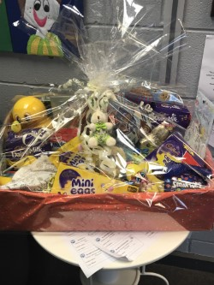
Eco-Council.
'Well done to Eco - Council, we
have achieved Silver Award! We are
now working towards the
Green Flag Award, which is the
highest award for Eco – Schools.
Wish us luck!’
Year 3 and 4 Easter Concert

Parents of our Year 3 and 4 children are welcome to join us for their Easter Concert where they will celebrate the Easter story.
Easter Egg Competition
Don’t forget to return your entry to school on Wednesday 3rd April. Due to limited space can you please ensure your design is no bigger than a a shoe box.
No real eggs to be used due to a serious egg allergy within school.
School Expectations

Please can we remind you about our expectations
for uniform and conduct on the school grounds

Black school shoes, no trainers
Bows should be Navy, Blue or Black
P.E. kit in school at all times
Outdoor kit needed for children from Year 2 through to Year 6
No chewing gum
Bikes-children must wear a helmet riding to school, they must not ride their bike or scooter on the school grounds
Dogs are not permitted on the school grounds
Mobile phones should only be brought by children walking to school on their own. They must be handed into the school office in the morning and collected at the end of the day.
Diary Dates

Monday 1st April @1pm
Year 5 Brass Assembly
Wednesday 3rd April @ 9.15am
Year 3 and 4 Easter Concert
Friday 5th April
School closes for Easter
Tuesday 23rd April
School re-opens for Summer Term
Tuesday 30th April
Road Safety Day
and
Year 6 shared learning and lunch 10.30-11.45am
and
PTA meeting @ 3pm
Wednesday 1st May @ 10.30-11.45am
Year 4 shared learning and lunch

