St Luke’s CE Primary
Year 4
Summer 1
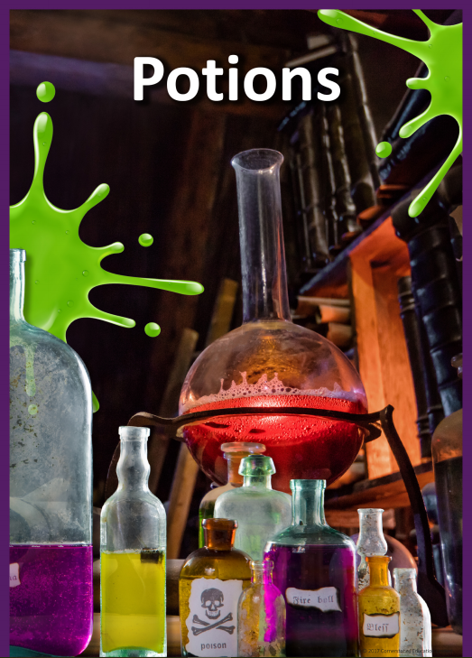
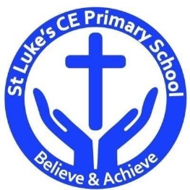
Discrete Learning Subjects
Main Learning Focus in English:
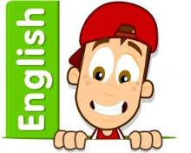
Fiction: Macbeth Retold in modern-day English by C.A. Plaisted
Non-fiction: Non-chronological reports on living things

Speaking and listening
- Participation in class and group discussions
- Explaining and justifying opinions about texts
- Learning new drama skills
Reading
- Shared Reading – reading a text chosen by the children with the class
- Guided Reading – reading with the teacher in small groups Individual & paired reading
- Using reading skills to obtain information
- Answering ‘big questions’
Writing
- Using Fantastics to develop writing
- Planning and structuring different texts
- Writing a newspaper report
- Writing a play-script
- Writing a non-chronological report
- Handwriting
Grammar and Punctuation
- Revising the use of punctuation previously taught
- extending the range of sentences with more than one clause by using a wider range of conjunctions
- using conjunctions, adverbs and prepositions to express time and cause
- using commas after fronted adverbials
- indicating possession by using the possessive apostrophe with singular and plural nouns
- using and punctuating direct speech
Spelling
- Words from statutory and personal spelling lists
- Proofreading for words on statutory list
Handwriting
- Revising letter joins formation
- Improve skills in joining writing

Main Learning Focus in Mathematics:

In Decimals children will learn about:  - Make a whole  - Write decimals  - Compare decimals  - Order decimals  - Round decimals  - Halves and quarter | In Measurement children will learn about:  - Pounds and pence  - Ordering amounts of money  - Using rounding to estimate money  - Hours, minutes and seconds  - Years, months, weeks and days  - Analogue to digital –12 hour  - Analogue to digital –24 hour

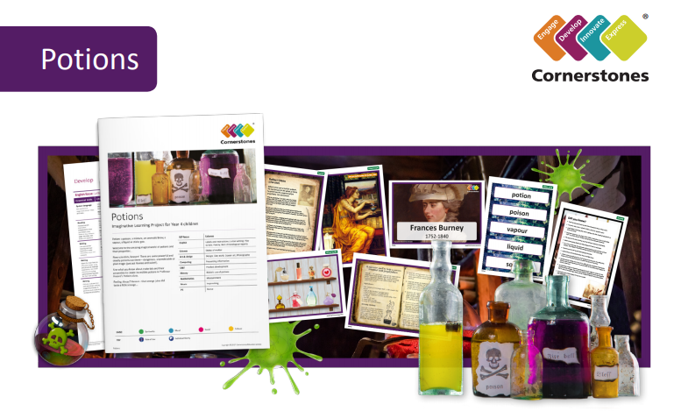

Poisonous potions, aromatic brews, vapour or a sticky goo… Welcome to the amazing world of potions!
We’ll sort everyday items into solids, liquids and gases. Using our investigation skills we’ll explore capacity and the properties of liquids. We’ll also design fabulous bottles for magical potions. Becoming super scientists,we’ll investigate chemical reactions and states of matter. We’ll research the use of anaesthetic and learn what life was like without it! The play, Macbeth will inspire us to write scripts, and we’ll think of an alternative ending for this tragic
tale. We’ll write spells with magical, strange or gruesome effects – what ingredients will we use? It will be great fun to make chocolates and bath bombs! We’ll also create canvas art on a large scale!

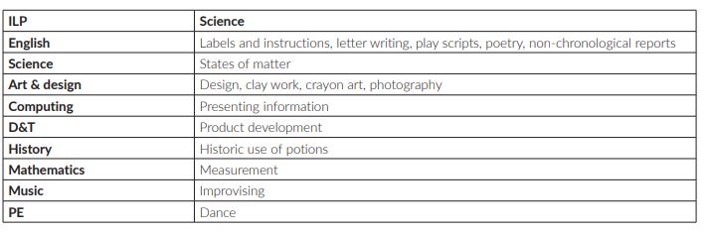
Help your child prepare for their project
‘Double, double toil and trouble; fire burn and cauldron bubble.’ Why not hunt around the house to track down a wide variety of items and sort them into solids, liquids and gases? You could also sketch interesting bottles or containers that you have at home. Alternatively, you could try baking something new together, thinking about how the ingredients change when you mix and cook them.

