St Luke’s CE Primary
Summer 1
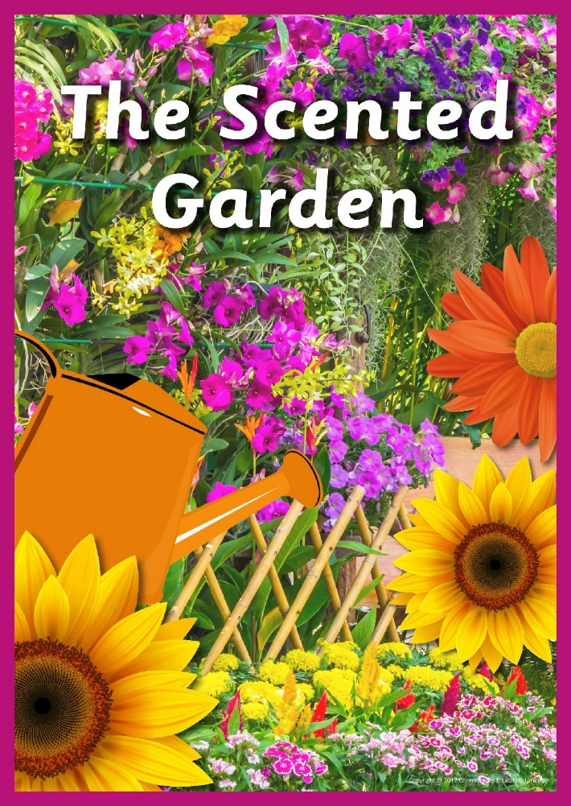

Year 2

The scented garden

Discrete Learning Subjects
Main Learning Focus in English:
Range: Fiction – Lila and the secret of rain. Poetry – Whatever the Weather
Speaking and listening.
Participation in class and group discussions Explaining and justifying opinions about texts
Preforming poetry
Reading
Shared Reading – reading the class book
Guided Reading – reading with the teacher in small groups Individual reading (from the school schemes)
Using reading skills to obtain information
Reading comprehension
Writing
- Write a long piece of text about a real event in one go.
- Write sentences about things they have done and that others have.
Grammar and Punctuation
- Use co-ordination (using or, and, but) and some subordination (using when, if, that, because) to join clauses.
- Use the progressive form of verbs in the present and past tense to make actions in progress e.g. she is drumming, he was shouting.
- Use present and past tense mostly correctly.
Spelling
- Recap of phase 5 and 6 letters and sounds.
Handwriting
- Form lower-case letters of the correct size relative to one another using tails and flicks.
- Write capital letters and digits of the correct size, orientation and relationship to one another and to lower case letters.

Main Learning Focus in Mathematics:
Working through our passports and practicing on Times table Rockstars.
*I can tell what the time is in hours and half past the hour. I can draw these on
a clock face
*I can tell when it is quarter past or quarter to an hour. I can draw these on a
Clock.
*I can tell the time to 5 minutes.
*I can solve problems with time.
*I can put different events in order and compare them.
*I can tell you how many minutes are in an hour and how many hours are in a
day.
*SATs revision.

