St Luke’s CE Primary
Summer 1

Year 1

Bright Lights, Big City
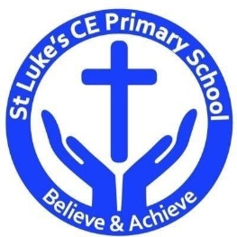
Discrete Learning Subjects
Main Learning Focus in English:
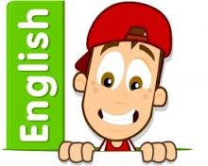
Range: The Queen’s Handbag. Narrative. Activities will include:
Speaking and listening.
Participation in class and group discussions Explaining and justifying opinions about texts Learning new drama skills
Taking on the role of a character–hot seating
Reading
Shared Reading – reading an enlarged text with the class Guided Reading – reading with the teacher in small groups
Writing
Planning and structuring a narrative text
Improving story writing skills
Instructions
Grammar and Punctuation
Revising the use of capital letters, full stops and finger spaces
Continuing to use commas
Using inverted commas
Understanding how to write a 2A sentence
Understanding what a verb is
Ensuring their sentences make sense by checking
Using the conjunction ‘and’ and ‘because’
Introduce alliteration and metaphors
Spelling
Developing a range of spelling strategies Using sounds from Phase 2 to 5
Spelling some/most common irregular words
Handwriting
Revising basic letter formation
Looking at tails and flicks
Main Learning Focus in Mathematics:

Children will learn to:

- Count in multiples of twos, fives and tens.
- Measure and begin to record lengths and heights.
- Compare, describe and solve

practical problems for: lengths and heights (for example, long/short, longer/shorter, tall/short, double/half).
- Measure and begin to record mass/weight, capacity and volume.
- Compare, describe and solve practical problems for mass/weight: [for example, heavy/light, heavier than, lighter than]; capacity and volume [for example, full/empty, more than, less than, half, half full, quarter]

