St Luke’s CE Primary
Summer 1

Year 3

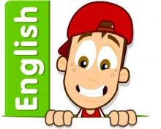

Discrete Learning subjects -

Main Learning Focus in English:
Range: Peter Pan Narrative, Non-fiction texts: Information text
Activities will include:
Speaking and listening.
Participation in class and group discussions Explaining and justifying opinions about texts Learning new drama skills
Reading
Shared Reading – reading an enlarged text with the class Guided Reading – reading with the teacher in small groups Individual & paired reading
Using reading skills to obtain information
Writing
Developing writing for a range of purposes and audiences Improving story writing skills
Planning and structuring different texts
Grammar and Punctuation
Revising the use of capital letters, full stops, commas and exclamation marks Punctuating sentences accurately using speech marks and question marks
Spelling
Words from statutory and personal spelling lists
Proofreading for words on statutory list

Handwriting
Revising letter joins formation
Main Learning Focus in Mathematics:

Children will learn to:

Find equivalent fractions
Compare fractions Order fractions
Add fractions Subtract fractions
Know many hours in day, months and years are in periods of time
Tell the time to 5 minutes
Tell the time to the minute
Understand AM and PM and the 24 hour clock
Find durations of events and compare the duration
Measure time in seconds

