St Luke’s CE Primary
Summer 2
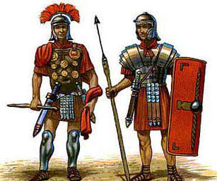

Why were the Romans so powerful?
St Luke’s CE Primary – Contextual Learning Unit on The Romans
Lead Subject Focus: History Subsidiary Learning Focus: R.E and Art
English focus: ‘Escape from Pomepii’
Discrete Learning Areas:
English Music
Mathematics French PSHE
Computing Religious Education Physical Education
historical Contextual Learning
- To learn about the Roman Empire
- To learn about Roman Numerals

- To learn if the romans left anything behind.

- To learn about the life of a roman child.

- To learn about the main religion on Rome.

Art
To learn about mosaics.
To create a mosaic.
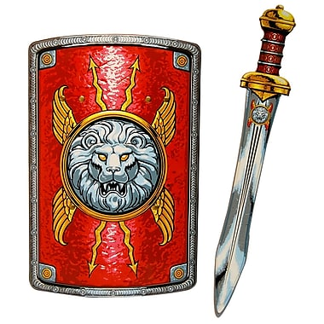

R.E
To learn about the pilgrimage of Christianity.
What famous ancient sites are religious.

Discrete Learning Subjects
Main Learning Focus in English:
Range: Escape from Pompeii, rewriting short stories. Creating own stories. Character descriptions.
Activities will include:
Speaking and listening.
Participation in class and group discussions Explaining and justifying opinions about texts Learning new drama skills
Reading
Shared Reading – reading an enlarged text with the class Guided Reading – reading with the teacher in small groups
Reciprocal reading – whole class and in small groups.
Writing
Developing writing for a range of purposes and audiences Improving story writing skills
Writing pages for an information book Planning and structuring different texts
Grammar and Punctuation
Revising the use of capital letters, full stops, commas and exclamation marks Punctuating sentences accurately using speech marks and question marks Ensuring grammatical agreement
Spelling
Developing a range of spelling strategies Using words ending with ‘s’ ‘ed’ and ‘ing’ Spelling common irregular words
Improving the use of a dictionary as a spelling aid Using knowledge of prefixes and suffixes to spell words
Handwriting
Revising basic letter formation
Improve skills in joining writing
Main Learning Focus in Mathematics:
Children will learn to:
To understand decimals
To relate decimals to money.
To find the change if buying items.
To be able to add 3 or more decimals together.
To understand time (5 minutes)
To use time to solve problems
To be able to read/ use bar models, charts, pie charts and line graphs.
To understand which 2d shapes make a 3d shape.
To find the properties of 2d and 3d shapes.
To use coordinates to be able to plot points of a quadrants.
To be able to plot points on two or more quadrants.
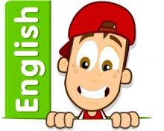
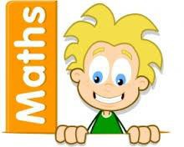

Main Learning Focus in Science: Plants and animals
To learn about different species of plants/ animals.
To understand how these lifeforms are suited to their environment.
Main Learning Focus in Computing: spreadsheets
To understand why we may use spreadsheets.
To find data and input into spreadsheets
To compare and analyze the date collected.
Main Learning Focus in Religious Education: Pilgrimage

Main Learning Focus in PSHE: friendship
Begin to develop confidence and responsibility and making the most of their abilities Preparing to play an active role as citizens
Developing good relationships and respecting the differences between people
Specialist Taught Subjects:
Main Learning Focus in Physical Education: Hockey/Rounders
To learn the basic rules and follow instructions
To learn to bowl (underarm)
To practice catching skills.
To learn how to shoot.
To learn how to save shots from going into the net.
Main Learning Focus in French: learning vocabulary at home.
To learn how to say – this is my home
To learn to say – the things in my home.
Create posters with vocabulary and pictures of your home.
Main learning Focus in Music: learning to read music
To learn about the treble staff.
To be able to read notes of a treble staff.
To create a basic piece of music.
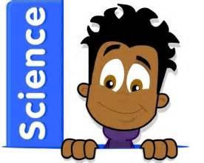
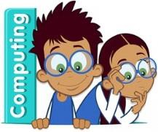

Self Assured Learner - Aspect Development
Exploring and taking Risks with Learning | The 4Rs (Resourcefulness – Reflectiveness – Relationships – Resilience)
Creating and Thinking Critically | Blooms Taxonomy – Thinking Hats –
Active Learning | Kagan Structures
Reflecting on work and being proud of own achievements | ROLE - ROLO

