Science
- Record data and results of increasing complexity using diagrams, charts and graphs.
- Record and present findings from enquiries, including conclusions.
- Take measurements using a range of scientific equipment.
- Identify scientific evidence which has been used to support ideas.

Design & Technology
- Select from a range of tools to perform practical tasks.
- Prepare and cook a range of dishes using a range of cooking techniques.
- Investigate and analyse a range of existing products.
- Build structures.

St Luke’s CE Primary – Curriculum Web
Year 2 Summer 2 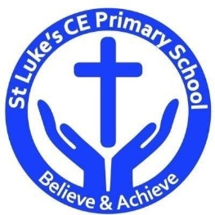

Beachcomber

Discrete Learning Areas:
English Music
Mathematics French PSHE
Computing Religious Education Physical Education

Discrete Learning Subjects
Main Learning Focus in English:
Range: Fiction – Winnie at the seaside Poetry – Whatever the weather
Speaking and listening.
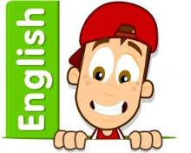
Participation in class and group Discussions explaining and justifying Opinions about texts
Preforming poetry
Reading
Shared Reading – reading the class book
Guided Reading – reading with the teacher in small Groups Individual reading (from the school schemes)
Using reading skills to obtain information
Reading comprehension
Writing
- Write
- Write sentences about things they have done and that others have.
Grammar and Punctuation
- Use co-ordination (using or, and, but) and some subordination (using when, if, that, because) to join clauses.
- Use the progressive form of verbs in the present and past tense to make actions in progress e.g. she is drumming, he was shouting.
- Use present and past tense mostly correctly.
Spelling
- Apostrophes for possession.
- Adding suffix Phase 6 phonics.
Handwriting
- Form lower-case letters of the correct size relative to one another using tails and flicks.
- Write capital letters and digits of the correct size, orientation and relationship to one another and to lower case letters.

Main Learning Focus in Mathematics:
Children will learn to:
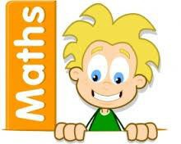
- Describe movement and turns
- Make patterns with shapes
- Compare mass
- Measure mass in grams
- Measure mass in kilograms
- Compare capacity
- Measure using millilitres
- Measure using litres
- Apply counting in 2’s, 5’s and 10’s skills when reading different thermometers.
- Consolidate skills learnt in Year 2.

Main Learning Focus in Science:

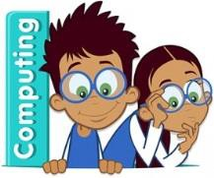
Main Learning Focus in Computing:

Main Learning Focus in Religious Education:

Main Learning Focus in PSHE:

Main Learning Focus in Physical Education:
Work will include individual, group and paired activities

Main learning Focus in Music:
Listening to, making, exploring and discussing sounds Recognising different sources of sounds

