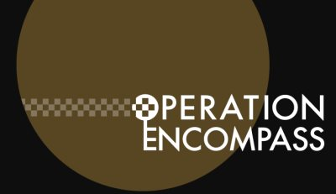

As part of St Luke’s commitment to keeping children safe, we are proud to be part of Operation Encompass.

Operation Encompass is a unique Police and education early intervention safeguarding partnership which supports children and young people exposed to domestic abuse.

Being part of Encompass means our school will receive a notification from Greater Manchester Police before the start of the next school day when a child or young person has been involved in or exposed to a domestic abuse incident the previous day. The information is given in confidence to the schools Key Adult and will enable us to provide the best possible support for the child.

The Key Adults at our school are Mrs Farrall, Mrs Cropper, Mrs Spears-Corry and Mrs Shepherd. If you have any questions or wish to know more about our involvement in Operation Encompass, please do not hesitate to contact the school office.

