St Luke’s CE Primary
Reception

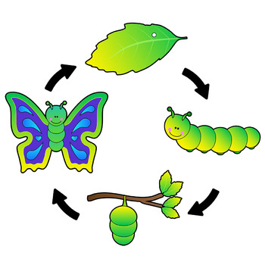
Summer Two

Lifecycles, Growing and Changes

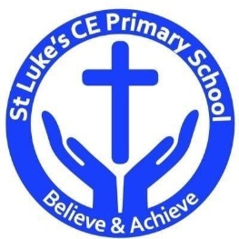

St Luke’s CE Primary – Contextual Learning Unit on lifecycles, growing and changes
Lead Subject Focus: Literacy
Subsidiary Learning Focus: Communication and Language, Expressive arts and design, Understanding the World.

Literacy: Contextual Learning
- Enjoys an increasing range of non-fiction books.
- To know that information can be retrieved from books and computers in relation to animals.
- Uses vocabulary and forms of speech that are increasingly influenced by their experiences of books.
- To read simple sentences in non-fiction books and starting to become more fluent when reading.
- To use phonics knowledge to decode regular words and read them aloud accurately, starting to become more fluent.
- To also read some common irregular words.
- Children to demonstrate understanding when talking with others about what they have read.
- To write simple sentences which can be read by themselves and others.
- To spell some words correctly and others that are phonetically plausible.
- To continue a rhyming string.
- To write some irregular common words.

Understanding the World
- Looks closely at similarities, differences, patterns and change.
- They talk about the features of their own immediate environment and how environments might vary from one another, looking at different animal habitats.
- They select and use technology for particular purposes.
- To use a simple computer program to create images of animals.
- Children know that other children don’t always enjoy the same things as they do and are sensitive to this.
- To make observations of animals and plants and explain why some things occur, and talk about changes.

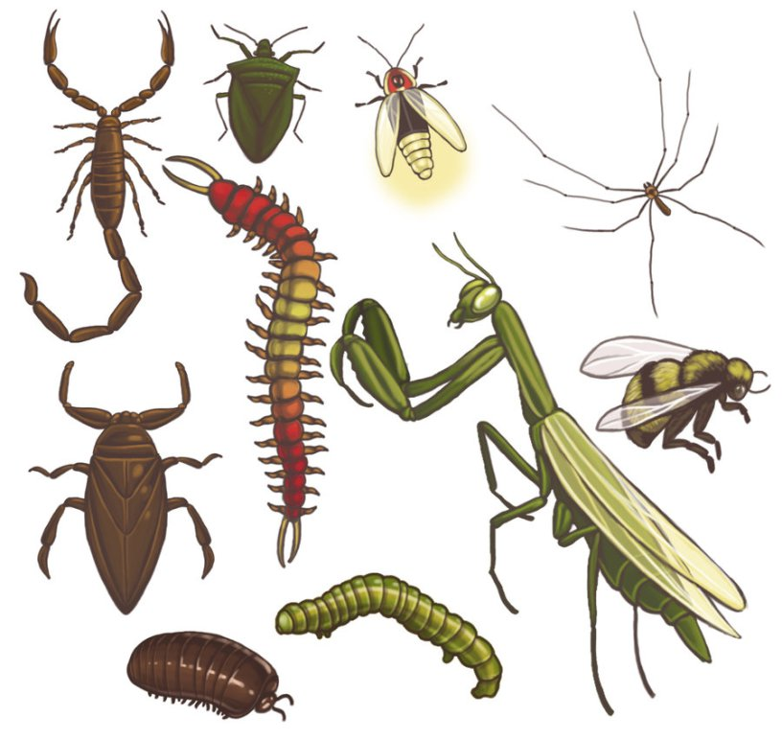

Communication and Language
- Children use language related to animals and changes they have observed within their play and when discussing with others. Uses language to imagine and create roles.
- Links statements and sticks to a main theme or intention.
- Uses talk to organise, sequence, and clarify thinking, ideas, feelings and events.
- Children use past, present and future tense accurately.
- They answer ‘how’ and ‘why’ questions about their experiences and in response to stories or events.
- Children express themselves effectively, showing awareness of listeners’ needs.
- To develop their own narratives and explanations by connecting ideas or events.

Discrete Learning Subjects
Main Learning Focus – Physical development
- Holds pencil near point, between first two fingers and thumb and uses it with good control.
- They handle equipment and tools effectively, including pencils for writing.
- Use scissors safely and with good control. Cuts out objects accurately and around the lines.
- Eats a healthy range of foodstuffs and understands need for variety in food.
- Shows some understanding that good practices with regard to exercise, eating, sleeping and hygiene can contribute to good health.
- Practices some appropriate safety measures without direct supervision.
- Children show good control and co-ordination in large and small movements.
- They move confidently in a range of ways, safely negotiating space.
- Children know the importance for good health of physical exercise, and a healthy diet, and talk about ways to keep healthy and safe.
Main Learning Focus – Mathematics
- Begins to identify own mathematical problems based on own interests and fascinations.
- Children count reliably with numbers from 1-20, place them in order saying which number is one more and one less than a given number.
- Using numerals and objects to add and subtract single digit numbers and count on or back to find the answer.
- To use everyday language related to money.
- They solve problems, including doubling, halving and sharing.
- They recognise, create and describe patterns.
- They explore characteristics of everyday objects and shapes and use mathematical language to describe them.
Main Learning Focus – Personal, Social and Emotional Development
- Children play co-operatively, taking turns with others.
- To take account of one another’s ideas about how to organise their activity in play.
- To show sensitivity to others’ needs and feelings, and form positive relationships with adults and other children.
- Children are confident to try new activities, and say why they like some activities more than others.
- They are confident to speak in a familiar group, will talk about their ideas, and will choose the resources they need for their chosen activities.
- They adjust their behavior to different situations, and take changes of routine in their stride.
- They say when they do or don’t need help.
Main Learning Focus- Expressive Arts and Design
- They safely use and explore a variety of materials, tools and techniques, experimenting with colour, design, texture, form and function.
- To plan, design and create their own animal images and habitats.
- Children use what they have learnt about media and materials in original ways, thinking about uses and purposes.
- They represent their own ideas, thoughts and feelings through design and technology, art, music, dance, role play and stories.
- To continue having a story line in their play and incorporate the knowledge they have learnt in class to apply to their play.
- To sing songs, make music and dance, and experiment with ways of changing them.

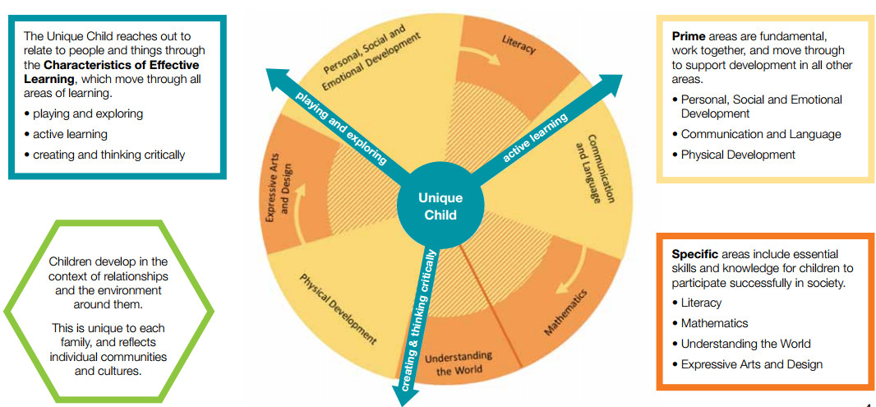

Homework
• Your child will bring home a reading book to share with you at home, please sign the reading record when you have read with your child. They should read a minimum of 4 times a week.
• Please practice key words (orange book).
• Please practice your child’s math’s passport targets with them at home.

Early Years- Overarching Principles
Every child is a unique child, who is constantly learning and can be resilient, capable, confident and self-assured;
• Children learn to be strong and independent through positive relationships.
• Children learn and develop well in enabling environments, in which their experiences respond to their individual needs and there is a strong partnership between practitioners and parents/carers; and
• Children develop and learn in different ways and at different rates. The framework covers the education and care of all children in early years’ provision, including children with special educational needs and disabilities.

