St Luke’s CE Primary – Curriculum Web
Year 3 Autumn 1
History
- To understand chronology and timelines
- To understand the role of an archeologist
- To understand prehistoric history and the different technological advancements in human history.

History

- To understand time periods e.g – Stone Age, Bronze Age and Iron Age

- To draw comparisons between time periods

- To evaluate a design of a fort

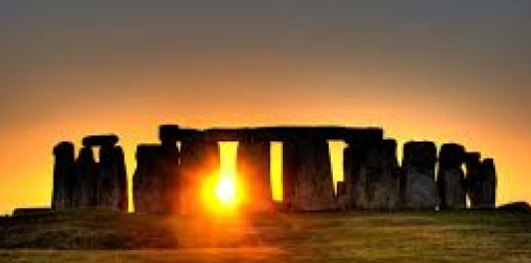

Tribal Tales

Discrete Learning Areas:
English Music Geography
Mathematics French PSHE
Computing Religious Education Physical Education Art/DT

Discrete Learning Subjects
Main Learning Focus in English: Adventure story ‘The Stone Age Boy’
Range: Adventure stories, letter writing. Activities will include:
Speaking and listening.
Participation in class and group discussions Explaining and justifying opinions about texts Discussing information inferred from a text
Reading
Guided Reading – reading with the teacher in small groups Individual reading – follow-up tasks from guided reading sessions
Focus on using information from the text to build written responses
Writing
Develop writing for a range of audiences and purposes
Create atmosphere and mood
Create characters and setting
Use fronted adverbials and complex sentences
Use non-fiction techniques to produce a letter.
Use formal language
Grammar and Punctuation
Grammatical structures used in more formal writing.
Punctuating sentences accurately
Sentence lengths vary for effect.
Use complex sentences
Spelling
Developing a range of spelling strategies Using words with spelling patterns from Y3 and Y4 Spelling List
Handwriting
Writing legibly with speed and fluency
Main Learning Focus in Mathematics: Number and place value
Children will learn to:
Hundreds
Compare numbers to 1000
Order numbers
Count in 50s
Representing numbers to 1000
Compare objects to 1000
Find 1, 10, 100 more or less than a given number
Number line to 1000
100s, 10s and 1s (2)
100s, 10s and 1s (1)

Main Learning Focus in Science:
To understand different plants/wildlife and how they have changed throughout history.

To understand the evolutionary development of homo sapiens.
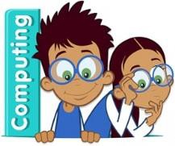
Main Learning Focus in Computing:
E-safety
Use technology safely, respectfully and responsibly
Coding

Main Learning Focus in Religious Education: What do people believe about God?
How different people see God.
Why do people believe in things that we cannot see?

Main Learning Focus in PSHE:
Friendship
Do not rub it in, rub it out.

Main Learning Focus in Physical Education:
Work will include individual, group and paired activities
Health and well-being
Healthy eating
How exercise effects the body
Football and athletics
Main Learning Focus in French:
Differences in French and English schools
Colours
Classroom commands
Basic greetings

Main learning Focus in Music:
Learning harvest songs.
Looking at rhyme
Rhythm

