St Luke’s CE Primary
Autumn 1

Paws, Claws and Whiskers

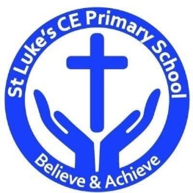

St Luke’s CE Primary – Contextual Learning Unit on Paws, Claws and Whiskers
Lead Subject Focus: Science Subsidiary Learning Focus: Art

Science

Learn about animals from around the world, where they live and comparing them to humans

Learn to work scientifically, creating bar charts and making predictions

Music

Animal songs

Art
Learn about patterns and textures through animal patterns

Collage

Painting

Geography
Using and making maps

Describing physical features

Discrete Learning Areas:
English
Mathematics French PSHE
Computing Religious Education Physical Education

Discrete Learning Subjects
Main Learning Focus in English:

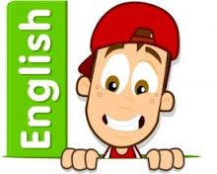
Range: Meerkat Mail. Narrative. Activities will include:
Speaking and listening.
Participation in class and group discussions Explaining and justifying opinions about texts Learning new drama skills
Reading
Shared Reading – reading an enlarged text with the class Guided Reading – reading with the teacher in small groups
Writing
Planning and structuring a narrative text
Improving story writing skills
Grammar and Punctuation
Revising the use of capital letters, full stops and finger spaces
Adding an adjective to a simple sentence
Ensuring their sentences make sense by checking
Spelling
Developing a range of spelling strategies Using sounds from Phase 2 to 4
Spelling some/most common irregular words
Handwriting
Revising basic letter formation
Looking at tails and flicks
Main Learning Focus in Mathematics:

Children will learn to:

- Count, read and write forwards from any number 0 to 10
- Count, read and writing backwards from any number 0 to 10
- Count one more
- Count one less
- One to one correspondence to start to compare groups
- Compare groups using language such as equal, more/greater, less/fewer
- Introduce = , > and < symbols

Main Learning Focus in Computing:
Learning how to log in
Online safety
Learning to care for equipment
Main Learning Focus in Religious Education: Who are Christians and what do they believe?
Explore rules and understand why we have them Investigate the rules people follow around the world
Understand religious symbols and why they are important to people
Main Learning Focus in PSHE:
Begin to understand other people’s feelings and how our actions affect them

Specialist Taught Subjects:
Main Learning Focus in Physical Education:
Work will include individual, group and paired activities Simple instruction games
Recognising how our bodies feel during and after exercise
Main Learning Focus in French:
Meet and greet other people
Numbers 1-10 in French
Main learning Focus in Music:
Listening to, making, exploring and discussing sounds Recognising different sources of sounds

Self Assured Learner - Aspect Development
Exploring and taking Risks with Learning | The 4Rs (Resourcefulness – Reflectiveness – Relationships – Resilience)
Creating and Thinking Critically | Blooms Taxonomy – Thinking Hats –
Active Learning | Kagan Structures
Reflecting on work and being proud of own achievements | ROLE - ROLO

