St Luke’s CE Primary
Reception

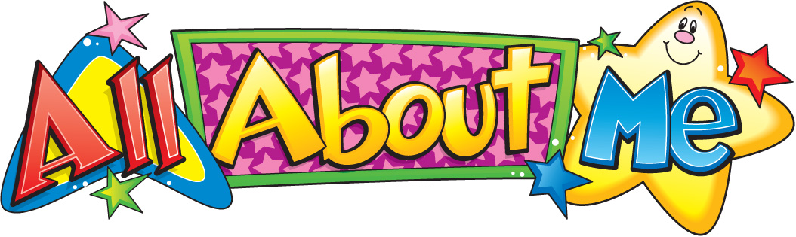

Autumn 1

All About Me

Physical Development.
- Zip coat up, fasten shoes and get changed for PE independently
- Use large PE apparatus and try new and different ways of moving
- Use small and large equipment and one-handed tools
- Promote fine motor control, hand/eye coordination by using threading activities, puzzles, small construction, etc.
- Repeat patterns such as in action rhymes and finger play
- Move with control and co-ordination in a range of ways

St Luke’s CE Primary – Contextual Learning Unit on All About Me
Lead Subject Focus: Personal, Social and Emotional Development
Subsidiary Learning Focus: Literacy, Communication and Language and Physical Development
Personal, Social and Emotional Development
- Introduce classroom/ school rules and routines showing understanding of other people’s needs including the adults who work in the setting
- Introduce circle time and calendar activities
- Empathise with ‘Titch’ (literacy) when reading story and share own family experiences with class during circle time
- Try out new activities and select resources independently
- Learn how to use the environment appropriately e.g. tiding up
- Show awareness of own and others needs
- Encourage children to play alongside and interact with other children who have similar interests to them

Literacy
- Listen to and distinguish initial sounds in own name and those of others
- Draw and paint sometimes giving meaning to marks
- Ask questions appropriately and listen to the response
- Sing and join in with Jolly Phonic Songs
- Begin to distinguish sounds in Jolly Phonics
- Begin to recognise/trace/copy/ write own name
- Begin to blend and segment CVC words
- To hold a book correctly and turn one page at a time
- To read books without words and then books with simple words and phrases

Communication and Language

- Respond to simple instructions and two part instructions
- Listen attentively to a range of stories
- Begin to join in familiar nursery rhymes and songs
- Begin to join in with repeated phrases within stories
- Use words and/or gestures appropriately
- Communication effectively with other children and staff
- To sit quietly during activities
- To follow a story without pictures

Main Learning Focus – Mathematics
- Counting objects and/or actions to 10 (20)
- Rote count to 10 (20) using a variety of ways including number rhymes, counting steps and playing number games e.t.c.
- Match number cards to numbers and/or amounts
- Daily counting using calendar, line – up, how many are here/not here today, how many chairs at the table, how many can play here, finger rhymes
- Use size language big/small to differentiate objects/toys in a variety of areas e.g sand/ water area
- Look at shapes try to match and name them –circle, square
- Show an interest in shapes in the environment e.g play with the different shapes in the construction and modelling area
- Begin to recognise how the shapes are similar and different
- Can you find these shapes in the environment- outside and inside?
- Create 3D models
- Look at the similarities and differences of 2 groups of objects – how are they different, which group has more...
- Sort groups by different objectives e.g. colour –primary colours

Main Learning Focus – Expressive Art and Design
- Be introduced to a wide variety of art materials, their purpose and how to use them safely
- Explore 2d and 3d art
- Observational drawings/paintings of faces using mirrors and window panels, noting similarities and differences
- Explore different materials/ textures to create collages of own face
- Make 3D structures with construction
- Explore music, sounds and sing songs

Main Learning Focus – Understanding the world
- Look at the past and present in relation to ‘self’
- Investigate and use construction materials of their self
- Ask why things happen and how they work
- Use ICT to support learning- create self –portrait on IWB
- Talk about self and immediate family in circle time

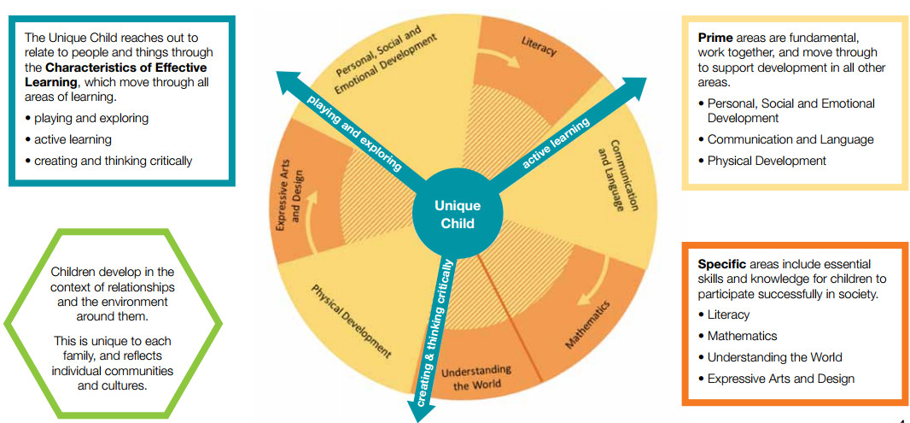

Homework
• Your child will bring home a reading book to share with you at home, please sign the reading record when you have read with your child. They should read a minimum of 4 times a week.
• Please practice key words (orange book). We will check keywords once a week.
• Please practice the targets in the maths passports with your child.
Early Years- Overarching Principles
every child is a unique child, who is constantly learning and can be resilient, capable, confident and self-assured;
• children learn to be strong and independent through positive relationships;
• children learn and develop well in enabling environments, in which their experiences respond to their individual needs and there is a strong partnership between practitioners and parents and/or carers; and
• children develop and learn in different ways and at different rates. The framework covers the education and care of all children in early years provision, including children with special educational needs and disabilities.

