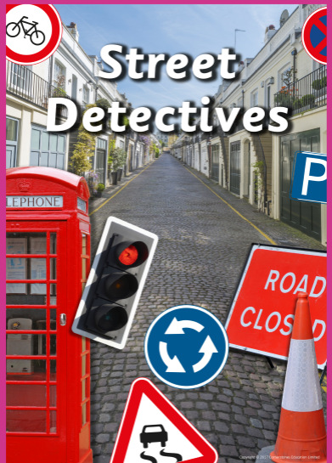
St Luke’s CE Primary – Curriculum Web
Year 2 Autumn 2 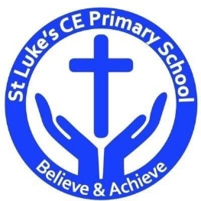
Geography
Describe and compare human and physical features seen in their local environment and other places in the world.
Identify and describe geographical human and physical features using an aerial photograph.
Draw simple map r plans using symbols for a key.

History
Describe how people, places and events in their own locality have changed over time.
Describe changes in the local area during their own lifetime and that of their parents and grandparents.
Describe how people, places and events in their own locality have changed over time.

Design & Technology
Selecting tools and materials to create a street in Heywood.

Science
Relate a material’s physical properties to its uses.

Discrete Learning Areas:
English Music Mathematics PSHE
Computing Religious Education Physical Education

Discrete Learning Subjects
Main Learning Focus in English:
Range: Fiction ‘On the way home’ and ‘My Christmas Star’.
Speaking and listening.
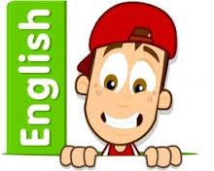
Participation in class and group Discussions explaining and justifying Opinions about texts
Reading
Shared Reading – reading the class book
Guided Reading – reading with the teacher in small groups Individual reading (from the school schemes)
Using reading skills to obtain information
Reading comprehension
Writing
- I can plan my writing by writing down my ideas or talking about them.
- I can write the correct spelling and punctuation in simple sentences I hear my teacher say.
- I can use capital letters and full stops to show where sentences start and end and sometimes use question marks.
- I can tell if a sentence is a question, command, exclamation or a statement.
- I can use description in my writing e.g the blue butterfly, plain flour, the man in the moon.
Grammar and Punctuation
- Use co-ordination (using or, and, but) and some subordination (using when, if, that, because) to join clauses.
- Use the progressive form of verbs in the present and past tense to make actions in progress e.g. she is drumming, he was shouting.
- Use present and past tense mostly correctly.
Spelling
- Phase 5 writing focus
- Phase 6
- I can spell some words which have been shortened.
Handwriting
- Form lower-case letters of the correct size relative to one another using tails and flicks.
- Write capital letters and digits of the correct size, orientation and relationship to one another and to lower case letters.
Main Learning Focus in Mathematics:
Children will learn to:
- Add a 2-digit and 1-digit number – crossing ten
- Subtract a 1-digit number from a 2-digit number – crossing ten
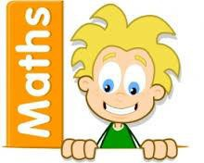
- Add two 2-digit numbers – crossing ten
- Subtract a 2-digit number from a 2-digit number – crossing ten
- Know my bonds to 100
- Add three 1-digit numbers
- Count money – pence and pounds/notes and coins.
- Select money
- Compare money
- Find totals, difference and change.
Solve 2 Two-step money problems

Main Learning Focus in Computing:

Questioning
- To show that the information provided on pictograms is of limited use beyond answering simple questions.
- To use 2Question (a binary tree) to answer questions.
- To use a database to answer more complex search questions. To use the Search tool to find information.
Main Learning Focus in Religious Education:

Who is a Muslim and what do they believe?
- Talk about some simple ideas about Muslim beliefs about God, making links with some of the 99 Names of Allah.
- Re-tell a story about the life of the Prophet Muhammad.
- Recognise some objects used by Muslims and suggest why they are important.
- Identify some ways Muslims mark Ramadan and celebrate Eid-ul-Fitr and how this might make them feel.
- Find out about and respond with ideas to examples of cooperation between people who are different.

Christianity – The Christmas Story.

Main Learning Focus in PSHE:

- F.R.E.S.H – The knowledge to make healthy choices and create a positive relationship with physical activity.
- HeartSmart – Don’t forget to let love in!
Main Learning Focus in Physical Education:
Work will include individual, group and paired activities.

Football and athletics

Health and well-being

Indoor PE Monday and Outdoor PE Thursday and Friday

Main learning Focus in Music:

Ho, ho, ho – Charanga
Christmas songs

Main learning Focus in French:
Greetings
Numbers to 10 in French.

