St Luke’s CE Primary – Curriculum Web
Year 3 Autumn 2 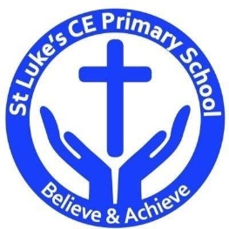
D &T
- Select appropriate tools and explain choices
- To design packaging
- To design and make a healthy food product

Science
- To understand food groups
- To understand how different food groups, help our bodies.
- To understand the term balanced diet.
- To design a recipe for a healthy food product

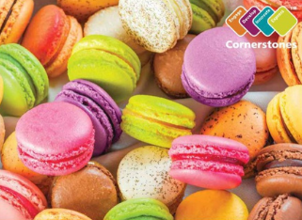

Scrumdidlyumptious

Discrete Learning Areas:
English Music Geography
Mathematics French PSHE History
Computing Religious Education Physical Education Art/DT

Discrete Learning Subjects
Main Learning Focus in English: Adventure story ‘The Stone Age Boy’
Range: Adventure stories, letter writing. Activities will include:
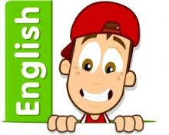
Speaking and listening.
Participation in class and group discussions Explaining and justifying opinions about texts Discussing information inferred from a text
Reading
Guided Reading – reading with the teacher as a class and in small groups Individual reading – follow-up tasks from guided reading sessions
Focus on using information from the text to build written responses
Writing
Develop writing for a range of audiences and purposes
Create setting descriptions
Create characters and setting
Use complex sentences
Use non-fiction techniques to produce a letter.
Use formal language
Grammar and Punctuation
Grammatical structures used in more formal writing.
Punctuating sentences accurately
Punctuating speech
Use the suffix ‘ly’ to create adverbs
Spelling
Developing a range of spelling strategies Spelling homophones
Y3 and Y4 Spelling List
Handwriting
Joining letters and writing legibly
Main Learning Focus in Mathematics: Number and place value
Children will learn to:
Multiplication – equal groups Multiplying by 3
Dividing by 3
The 3 times-table
Multiplying by 4
Dividing by 4
The 4 times-table
Multiplying by 8
Dividing by 8
The 8 times-table

Compare numbers to 1000
Order numbers
Count in 50s

Main Learning Focus in Science:
To understand food groups
To understand nutrition
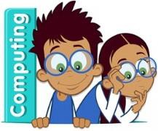
Main Learning Focus in Computing:
E-safety
Use technology safely, respectfully and responsibly
Typing

Main Learning Focus in Religious Education: What do people believe about God?
Understanding how other religions view God

Main Learning Focus in PSHE:
Too much selfie isn’t healthy
Main Learning Focus in Physical Education:
Work will include individual, group and paired activities
Health and well-being
Healthy eating
How exercise effects the body
Gymnastics
Main Learning Focus in French:
About France
All about me
Main learning Focus in Music:
Rhythm

