St Luke’s CE Primary
Reception

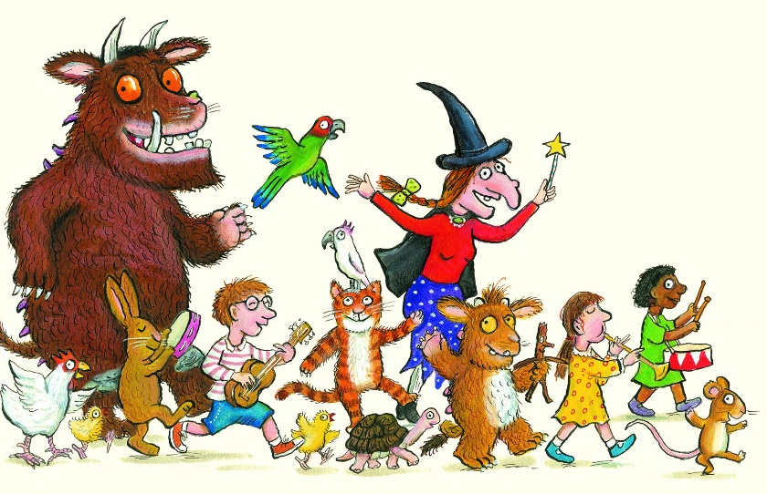

Autumn 2

Julia Donaldson

St Luke’s CE Primary – Contextual Learning Unit on All About Me
Lead Subject Focus: Literacy and Communication and Language
Subsidiary Learning Focus: Personal, Social and Emotional Development and Expressive Arts and Design

Expressive Arts and Design
- Create simple representations of events, people and objects.
- Chooses particular colours to use for a purpose.
- Introduces a storyline or narrative into their play.
- Plays alongside other children who are engaged in the same theme.
- Begins to build a repertoire of songs and dances.
- Explores the different sounds of instruments.
- Explores what happens when they mix colours.
- Experiments to create different textures.

Communication and Language
- Listens to a range of Julia Donaldson stories with increasing attention and recall.
- Joins in with repeated refrains and anticipates key events and phrases in rhymes and stories.
- Is able to follow directions (if not intently focused on own choice of activity).
- Able to follow a story without pictures or props.
- Listens and responds to ideas expressed by others in conversation or discussion.
- Uses language to imagine and recreate roles and experiences in play situations.
- Links statements and sticks to a main theme or intention.
- Uses talk to organise, sequence and clarify thinking, ideas, feelings and events.
- Introduces a storyline or narrative into their play.

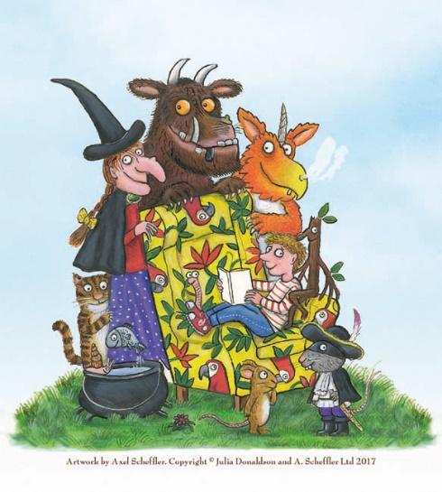

Literacy
- Sing and join in with Jolly Phonic Songs
- Begin to distinguish sounds in Jolly Phonics
- To write their own name independently
- To write recognisable letters and to link the letter to a sound
- To blend and segment CVC words
- To begin to read simple phrases using phonic knowledge
- To answer simple questions based on what they have read
- To discuss familiar stories
- To look at books independently and to hold it correctly and turn one page at a time

Personal, Social and Emotional Development
- To be aware of the classroom rules and daily routine.
- Can select and use resources for an activity.
- Confident to talk to other children in their play.
- Understands that own actions affect other people, for example, becomes upset or tries to comfort another child when they realise they have upset them.
- Keeps play going by responding to other children and begin to initiate play.
- Demonstrates friendly behavior with adults and children.

Main Learning Focus – Mathematics
- To discuss similarities and differences between objects
- To sort objects into two distinctive groups
- To discover that there is more than one way of sorting a group of objects
- To sort a collection of objects
- To notice inequality in groups
- To compare groups using more and fewer
- To add one more, up to 5
- To find one less, up to 5
- To discuss time
- To order a familiar day
- To accurately use language related to time
- To order numbers up to 5 and then 10

Main Learning Focus – Physical Development
- Experiments with different ways of moving.
- Jumps off an object and lands appropriately.
- Negotiates space successfully when playing racing and chasing games with other children, adjusting speed or changing direction to avoid obstacles.
- Travels with confidence and skill around, under, over and through balancing and climbing equipment.
- Shows a preference for a dominant hand
- Begins to form recognisable letters.
- Uses a pencil and holds it effectively to form recognisable letters, most of which are correctly formed.
- Eats a healthy range of foodstuffs and understands need for variety in food.
- Usually dry and clean during the day
- Shows understanding of how to transport and store equipment safely.

Main Learning Focus – Understanding the world
- To become familiar with a range of technology e.g. a computer laptop and iPad.
- To begin to use a simple computer program
- Look closely and compare similarities and differences in the living environment
- To join in and discuss family traditions
- To learn about different cultures and their traditions e.g. Diwali
- To celebrate festivals and traditions
- To learn about the story of Christmas.

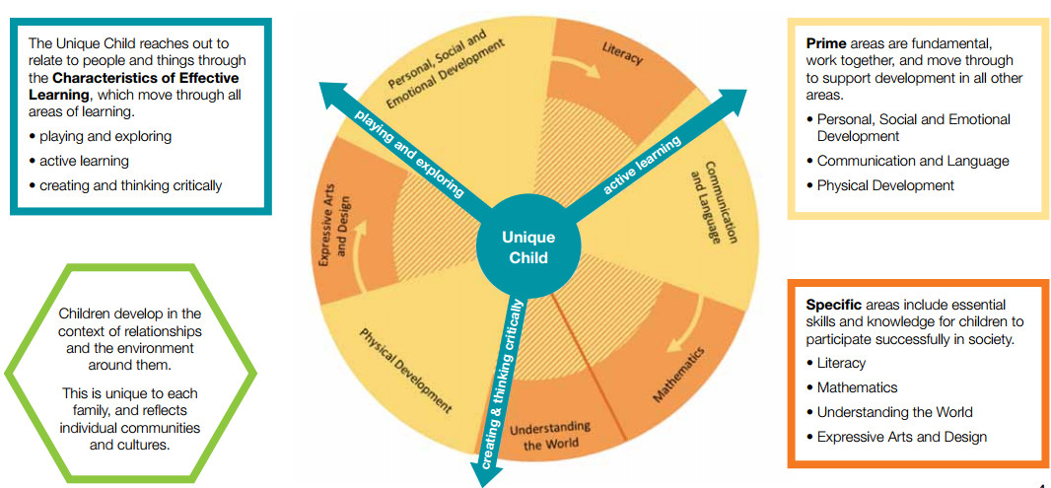

Homework
• Your child will bring home a reading book to share with you at home, please sign the reading record when you have read with your child. They should read a minimum of 4 times a week.
• Please practice key words (orange book). We will check keywords once a week.
• Please practice the targets in the maths passports with your child.
Early Years- Overarching Principles
every child is a unique child, who is constantly learning and can be resilient, capable, confident and self-assured;
• children learn to be strong and independent through positive relationships;
• children learn and develop well in enabling environments, in which their experiences respond to their individual needs and there is a strong partnership between practitioners and parents and/or carers; and
• children develop and learn in different ways and at different rates. The framework covers the education and care of all children in early years provision, including children with special educational needs and disabilities.

