St Luke’s CE Primary
Reception
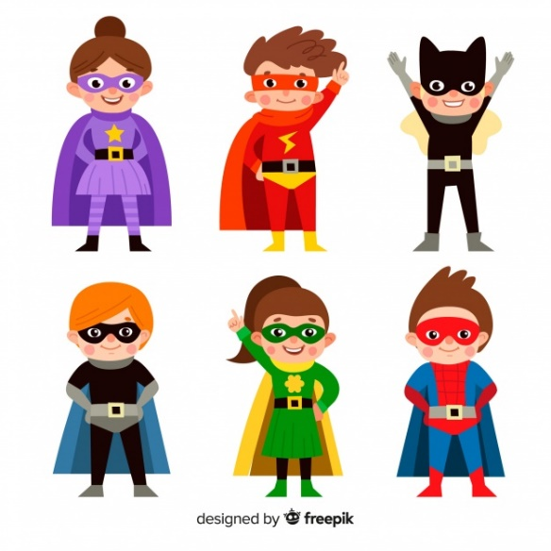

Spring 1

Superheroes

Main Learning Focus – Mathematics
- Recognises numerals 1 to 5.
- Compares two groups of objects, saying when they have the same number.
- Number bonds within 5.
- Numbers to 10
- Recites numbers in order to 10.
- Counts objects to 10, and beginning to count beyond 10.
- Comparing numbers within 10.
- Addition using numbers to 10.
- Finds the total number of items in two groups by counting all of them.
- Number bonds to 10.
- Counts an irregular arrangement of up to 10 objects.
- Recognise 2D and 3D shapes
- Spatial awareness
Main Learning Focus – Communication + Language and Literacy
- Respond and understand and two part instructions
- Listen attentively to a range of stories and recall familiar stories
- Write their name neatly on a line, forming letters correctly
- Draw and paint for a reason
- Listen to others
- Ask questions appropriately and listen to the response taking account of what the other person says
- Join in with phonics sessions
- Begin to distinguish phonemes in phonics sessions
- To blend and segment CVC words
- Begin to write lists, captions and labels for a purpose
- Begin to write short sentences for a purpose
- Read CVC words and understand a simple sentence
Main Learning Focus – Understanding the world
- To become familiar with a range of technology e.g. a computer laptop and iPad.
- To begin to use a simple computer program
- Look closely and compare similarities and differences in the living environment
- Shows an interest in different occupations and ways of life
- To join in and discuss family traditions
- To learn about different cultures and their traditions
- To celebrate others festivals and traditions
- To learn about Chinese New Year
Main Learning Focus – Being Imaginative
- Engages in imaginative role-play based on own first-hand experiences.
- Builds stories around toys, e.g. people needing a superhero to rescue them from an armchair ‘cliff’.
- Uses available resources to create props to support role-play.
- Captures experiences and responses with a range of media, such as music, dance and paint and other materials or words.
- Create simple representations of events, people and objects.
- Introduces a storyline or narrative into their play.
- Plays alongside other children who are engaged in the same theme.
- Plays cooperatively as part of a group to develop and act out a narrative.

