St Luke’s CE Primary
Spring 1

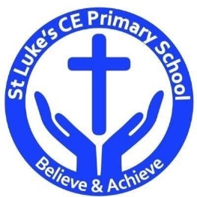

Year 3

Tremors
St Luke’s CE Primary – Contextual Learning Unit Nutrition and healthy eating.
Lead Subject Focus: Geography
Discrete Learning Areas:
English Music Science
Mathematics French PSHE
Computing Religious Education Physical Education
Geography
Contextual Learning

- To gather evidence to answer a geographical question or enquiry.

- To name and locate significant volcanoes and plate boundaries and explain why they are important.
- To describe the parts of a volcano or earthquake.
- To analyse maps, atlases and globes, including digital mapping, to locate countries and describe features studied
Art & D.T
Work in the style of a significant artist, architect or designer.

Science
To understand the different properties of rocks.
To be able to name the 3 different types of rocks
History
To study how Mount Vesuvius erupting effected the city of Pompeii.

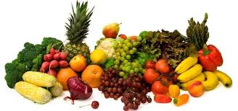

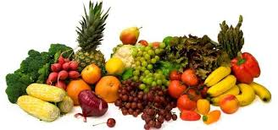

Discrete Learning Subjects
Main Learning Focus in English: Charlie and the Chocolate Factory
Range: Non-fiction texts (explanation and information), Instructional texts, Poetry, Diary entries. Activities will include:
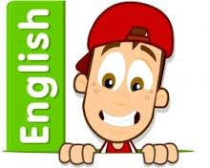
Speaking and listening.
Participation in class and group discussions Explaining and justifying opinions about texts Discussing information inferred from a text
Reading
Shared Reading – reading the Escape from Pompeii
Guided Reading – reading with the teacher in small groups Individual reading – follow-up tasks from guided reading sessions
Focus on using information from the text to build written responses
Writing
Developing writing for a range of purposes and audiences
Using appropriate grammar and vocabulary for specific genres of writing.
Writing non-fiction texts: information; explanation; instructions.
Structuring different texts
Grammar and Punctuation
Grammatical structures used in more formal writing.
Punctuating sentences accurately with the full range of punctuation taught at KS1 & year 3.
Using cohesive devices and layout devices appropriate to the text.
Spelling
Developing a range of spelling strategies Using words with spelling patterns from Y3&4
Using knowledge of prefixes and suffixes to spell words
Handwriting
Revising letter joins formation
Improve skills in joining writing

Main Learning Focus in Mathematics:
Children will learn to:
- Relationship between multiplying and dividing
- Times and divide by multiples of 10 up to 120.
- Multiple 2 digit by 1 digit
- Divide 2 digit by 1 digit
- Problem solving with division and multiplication.

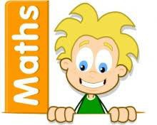

Main Learning Focus in Science: Rocks
To understand the different properties of rocks.
To be able to name the 3 different types of rocks
Main Learning Focus in Computing: Email

Learn how to craft and send emails.
Looking at how and why we send emails.
Main Learning Focus in Religious Education:
- To learn about different religious festivals.
- To learn about different ways we celebrate faith.

Main Learning Focus in PSHE:
Begin to develop confidence and responsibility
Preparing to play an active role as citizens
Discuss a healthy, safe lifestyle

Specialist Taught Subjects:
Main Learning Focus in Physical Education:
Work will include individual, group and paired activities Leading simple invasion, net and striking and fielding games
Developing a range of throwing and catching techniques for basketball Keeping score, developing rules and simple tactics within games
Recognising good performance and using this to improve skills
Record and discuss how our bodies feel during and after exercise and the benefits
Main Learning Focus in French:
Greetings and classroom vocabulary
Parts of the body in French.
Starting to write French words.
Main learning Focus in Music:
Lessons to be done by Rochdale music service. Children to learn how to play the ukulele

