Design and Technology
- Select from and use a wider range of materials and components.
- Use research and develop design criteria to inform the design of innovative, functional, appealing products
- Investigate and analyse a range of existing products.
- Evaluate their ideas and products against their own design criteria and consider the views of others to improve their work.
- Understand seasonality, and know where and how a variety of ingredients are grown, reared, caught and processed.
St Luke’s CE Primary – Curriculum Web
Year 5 Spring 1
Geography
- Locate the world’s countries, using maps to focus on Europe (including the location of Russia) and North and South America, concentrating on their environmental regions, key physical and human characteristics, countries, and major cities.
- Describe and understand key aspects of human geography, including: types of settlement and land use, economic activity including trade links, and the distribution of natural resources including energy, food, minerals and water.
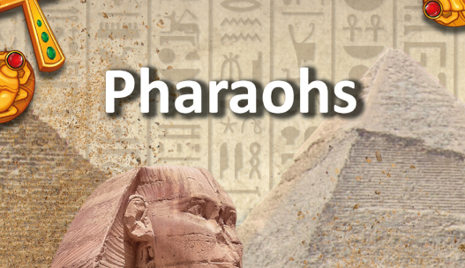

History
- Learn about the achievements of the earliest civilizations – an overview of where and when the first civilizations appeared and a depth study of Ancient Egypt.
Art and Design
- Improve their mastery of art and design techniques, including drawing, painting and sculpture with a range of materials (e.g. pencil, charcoal, paint, clay).
- Find out about great artists, architects and designers in history

Discrete Learning Areas:
English
Mathematics French PSHE
Computing Religious Education Physical Education

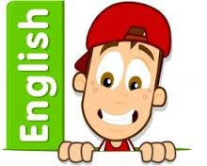
Discrete Learning Subjects
Main Learning Focus in English:
Range: Biographies and narratives
Speaking and listening.
- giving short speeches and presentations, expressing their own ideas and keeping to the point
Reading
Maintain positive attitudes to reading and an understanding of what they read by:
- continuing to read and discuss an increasingly wide range of fiction, poetry, plays, non-fiction and reference books or textbooks.
- identifying and discussing themes and conventions in and across a wide range of writing
- drawing inferences such as inferring characters’ feelings, thoughts and motives from their actions, and justifying inferences with evidence.
- summarising the main ideas drawn from more than 1 paragraph, identifying key details that support the main ideas
Writing
- selecting appropriate grammar and vocabulary, understanding how such choices can change and enhance meaning
- in narratives, describing settings, characters and atmosphere and integrating dialogue to convey character and advance the action
- proposing changes to vocabulary, grammar and punctuation to enhance effects and clarify meaning

Grammar and Punctuation
- Parenthesis
- Tenses

Spelling
- Creating nouns using suffixes
- Homophones
Handwriting
- write legibly, fluently and with increasing speed
Main Learning Focus in Mathematics:

Unit 7: Multiplication and Division
- Multiply up to a 4 digit number by a 1 or 2 digit number
- Divide a number up to 4 digits by a 1 digit number
- Interpret remainders
- Solve problems involving multiplication, division and remainders

Unit 8: Fractions (1)
- Find and use equivalent fractions
- Convert between improper fractions and mixed numbers
- Compare and order fractions
- Understand fractions as division
- Use fractions to show remainders

Unit 9: Fractions (2)
- Add and subtract fractions with the same denominator
- Add and subtract fractions, including mixed numbers, where one denominator is a multiple of another
- Solve word problems involving fractions

Main Learning Focus in Computing:
Game Creator
Main Learning Focus in Religious Education:

If God is everywhere, Why go to a place of worship?
Main Learning Focus in PSHE:

Too Much selfie isn’t healthy: Empathy. Exploring the importance of others and how to love them well.
Main Learning Focus in Physical Education:

Basketball and dance
Main Learning Focus in French:

- Say the nouns in French for members of their family.
- Tell somebody in French the members and age of a fictitious, historical or television family as a model to present and practise family vocabulary.
- Continue to count, reaching 100, to enable students to say the age of various family members.
- Understand the concept of mon, ma and mes in French.

