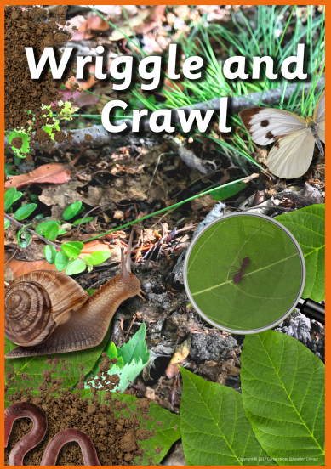
Science
Identify and name a variety of plants and animals in their habitats, including micro-habitats.
Find out about and describe the basic needs of animals, including humans, for survival (water, food and air).
Ask simple questions and recognise that they can be answered in different ways.
Perform simple tests.
Use their observations and ideas to suggest answers to questions.
Notice that animals, including humans, have offspring which grow into adults.

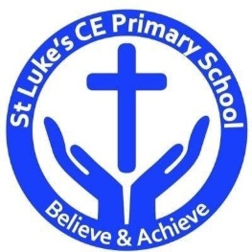St Luke’s CE Primary – Curriculum Web
Year 2 Spring 1
Geography
Develop a wide range of art and design techniques in using colour, pattern, texture, line, shape, form and space.
Use a range of materials creatively to design and make products.

Design & Technology
Understand where food comes from.
Select from and use a wide range of materials and components, including construction materials, textiles and ingredients, according to their characteristics.
Science
Use simple fieldwork and observational skills to study the geography of their school and its grounds and the key human and physical features of its surrounding environment.

Discrete Learning Areas:
English Music Mathematics PSHE
Computing Religious Education Physical Education

Discrete Learning Subjects
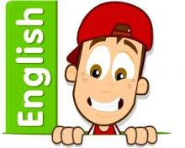
Main Learning Focus in English:
Non-fiction: Non-chronological report
Fiction ‘Arrrrrrgggggh Spider’
Speaking and listening.
Participation in class and group Discussions explaining and justifying Opinions about texts
Reading
Shared Reading – reading the class book
Guided Reading – reading with the teacher in small groups Individual reading (from the school schemes)
Using reading skills to obtain information
Reading comprehension
Writing
- I can plan my writing by writing down my ideas or talking about them.
- I can write the correct spelling and punctuation in simple sentences I hear my teacher say.
- I can use capital letters and full stops to show where sentences start and end and sometimes use question marks.
- I can tell if a sentence is a question, command, exclamation or a statement.
- I can use description in my writing e.g the blue butterfly, plain flour, the man in the moon.
Grammar and Punctuation
- Use co-ordination (using or, and, but) and some subordination (using when, if, that, because) to join clauses.
- Use the progressive form of verbs in the present and past tense to make actions in progress e.g. she is drumming, he was shouting.
- Use present and past tense mostly correctly.
Spelling
- Read, write Inc and Phase 6 Letters and sounds.
Handwriting
- Form lower-case letters of the correct size relative to one another using tails and flicks.
- Write capital letters and digits of the correct size, orientation and relationship to one another and to lower case letters.
Main Learning Focus in Mathematics:
Children will learn to:
- Making equal groups
- Sharing and grouping
- Dividing by 2
- Odd and even numbers
- Dividing by 5
- Dividing by 10
- Bar modeling – grouping
- Bar modelling – sharing
- Solving word problems – division
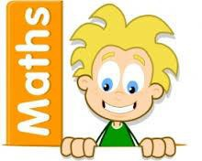
- Making tally charts
- Creating pictograms
- Interpreting pictograms
- Block diagrams
- Solving word problems
- Measuring in centimeters and meters
- Comparing lengths
- Ordering lengths
- Solving problems – lengths

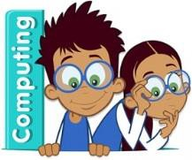
Main Learning Focus in Computing:
Effective searching:
- To understand the terminology associated with searching.
- To gain a better understanding of searching on the Internet.
- To create a leaflet to help someone search for information on the Internet.
- To understand that information put online leaves a digital footprint or trail. To begin to think critically about the information they leave online. To identify the steps that can be taken to keep personal data and hardware secure.
Spreadsheets:
- Reviewing prior use of spreadsheets
- Copying and Pasting Totaling tools
- Using a spreadsheet to add amounts
- Creating a table and block graph
Main Learning Focus in Religious Education:

Who is Jewish and what do they believe?
Talk about how the mezuzah in the home reminds Jewish people about God
Talk about how Shabbat is a special day of the week for Jewish people, and give some examples of what they might do to celebrate Shabbat
• Re-tell a story that shows what Jewish people at Shabbat might think about God, suggesting what it means
Re-tell a story that shows what Jewish people at the festivals of Chanukah might think about God, suggesting what it means
Main Learning Focus in PSHE:

- HeartSmart – Fake is a mistake!
Main Learning Focus in Physical Education:
Work will include individual, group and paired activities.

Outdoor – Target Games
Indoor – Dance ‘Under the sea’.

Outdoor PE Tuesday and Indoor PE Thursday
Main learning Focus in Music:
Zootime

This is a six-week Unit of Work. All the learning is focused around one song: Zootime. The material presents an integrated approach to music where games, the interrelated dimensions of music (pulse, rhythm, pitch etc.), singing and playing instruments are all linked.
Main learning Focus in French:
Animals

