St Luke’s CE Primary
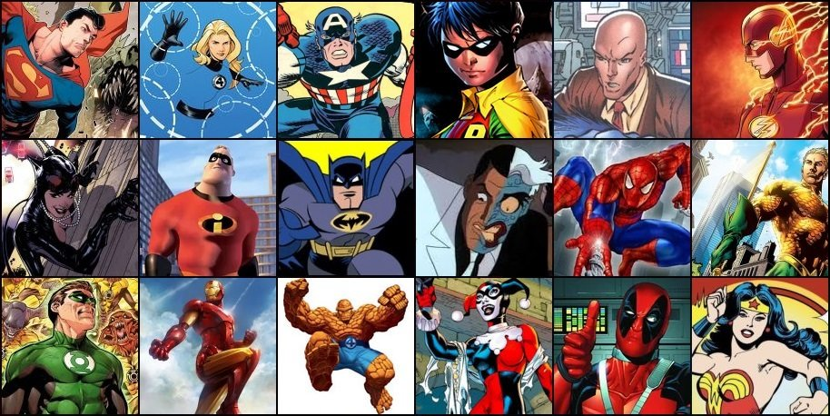
Spring 2

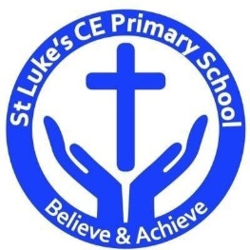

Year 3

Heroes and Villains
St Luke’s CE Primary – Contextual Learning Unit Music and Lyrics .
Lead Subject Focus: Music
Discrete Learning Areas:
English Music Geography
Mathematics French Art
Computing Religious Education Physical Education
Music
Contextual Learning

- To understand how music can affect our emotions/opinions of a person.

- To start to read and understand musical vocabulary.
- To compose and alter music to fit a particular need/style.
- To perform and arrange appropriate music for a topic.
PHSE
To discuss and explore emotions of ourselves and other in different situations.

Science
To understand how light travels
To understand how shadows are made.

History
To study historical heroes and heroines.

Discrete Learning Subjects
Main Learning Focus in English: Peter Pan
Range: Non-fiction texts (explanation and information), Instructional texts, Poetry, Diary entries. Activities will include:
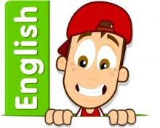
Speaking and listening.
Participation in class and group discussions Explaining and justifying opinions about texts Discussing information inferred from a text
Reading
Shared Reading – reading the Peter Pan
Guided Reading – reading with the teacher in small groups Individual reading – follow-up tasks from guided reading sessions
Focus on using information from the text to build written responses
Writing
Developing writing for a range of purposes and audiences
Using appropriate grammar and vocabulary for specific genres of writing.
Writing non-fiction texts: information; explanation; instructions.
Structuring different texts
Grammar and Punctuation
Grammatical structures used in more formal writing.
Punctuating sentences accurately with the full range of punctuation taught at KS1 & year 3.
Using cohesive devices and layout devices appropriate to the text.
Spelling
Developing a range of spelling strategies Using words with spelling patterns from Y3&4
Using knowledge of prefixes and suffixes to spell words
Handwriting
Revising letter joins formation
Improve skills in joining writing

Main Learning Focus in Mathematics:
Children will learn to:
- Understand pictograms
- Understand bar charts
- To start to read tables
- Problem solving with pictograms, bar charts and tables.

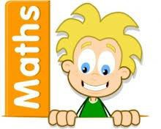

Main Learning Focus in Science: light and shadows.
To understand how light travels
To understand how shadows are made.
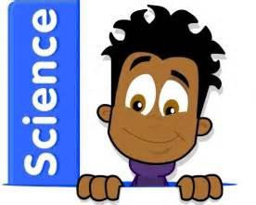
Main Learning Focus in Computing: simulations

Learn what a simulation is
Look for ways to solve simulations.
Main Learning Focus in Religious Education:
- To learn about different religious festivals.
- To learn about different ways we celebrate faith.

Main Learning Focus in PSHE:
Begin to develop confidence and responsibility
Preparing to play an active role as citizens
Discuss a healthy, safe lifestyle

Specialist Taught Subjects:
Main Learning Focus in Physical Education:
Work will include individual, group and paired activities Leading simple invasion, net and striking and fielding games
Developing a range of throwing and catching techniques for basketball Keeping score, developing rules and simple tactics within games
Recognising good performance and using this to improve skills
Record and discuss how our bodies feel during and after exercise and the benefits
Main Learning Focus in French:
Greetings and classroom vocabulary
Parts of the body in French.
Starting to write French words.
Main learning Focus in Music:
Lessons to be done by Rochdale music service. Children to learn how to play the ukulele

