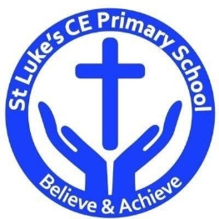St Luke’s CE Primary – Curriculum Web
Year 2 Spring 1
Music
- Identify the difference between rhythm and pulse.
- Carefully choose instruments to combine layers of sound, showing awareness of the combined effect.
- Use own voice in different ways, including using a loud or soft voice and sing simple repeated phrases.
Science
- Identify simple patterns and/or relationships using simple comparative language.
- Gather data, record and talk about their findings in a range of ways, using scientific vocabulary.
- Do things in the correct order, when performing a simple test and begin to recognise when something is unfair.
- Decide with help, how to group materials, living things and objects noticing changes over time and beginning to see patterns.

Beat, band and boogie
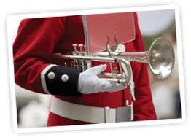

Design & technology
- Design and make a musical instrument. (shared learning)
- Explain how closely finished products meets their design criteria and say what they could do better in the future.

Discrete Learning Subjects
Main Learning Focus in English:
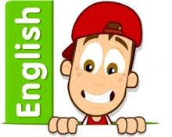
Range: Fiction – The leopard’s Drum. Poetry and nursery rhymes
Speaking and listening.
Participation in class and group discussions Explaining and justifying opinions about texts
Preforming poetry
Reading
Shared Reading – reading the class book
Guided Reading – reading with the teacher in small groups Individual reading (from the school schemes)
Using reading skills to obtain information
Reading comprehension
Writing
- Write a long piece of text about a real event in one go.
- Write sentences about things they have done and that others have.
Grammar and Punctuation
- Use co-ordination (using or, and, but) and some subordination (using when, if, that, because) to join clauses.
- Use the progressive form of verbs in the present and past tense to make actions in progress e.g. she is drumming, he was shouting.
- Use present and past tense mostly correctly.
Spelling
- Apostrophes for possession.
- Adding suffix Phase 6 phonics.
Handwriting
- Form lower-case letters of the correct size relative to one another using tails and flicks.
- Write capital letters and digits of the correct size, orientation and relationship to one another and to lower case letters.

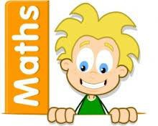
Main Learning Focus in Mathematics:
Working through our passports and practicing on Times table Rockstars.

Children will learn to:

- Identify and describe the properties of 2-D shapes, including the number of sides and line symmetry in a vertical line
- Identify and describe the properties of 3-D shapes, including the number of edges, vertices and faces
- Compare and sort common 2-D and 3-D shapes and everyday objects
- Order and arrange combinations of mathematical objects in patterns and sequences
- Recognise, find and name a half as one of two equal parts of an object, shape or quantity
- Recognise, find and name a quarter as one of four equal parts of an object, shape or quantity
- Recognise, find, name and write fractions 1/3, 1/4, 2/4 and 3/4 of a length, shape, set of objects or quantity
- Write simple fractions for example, 1/2 of 6 = 3 and recognise the equivalence of 2/4 and 1/2

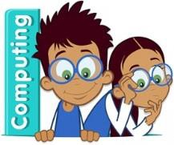
Main Learning Focus in Computing:
Making music:
- To be introduced to making music digitally using 2Sequence. To explore, edit and combine sounds using 2Sequence.
- To add sounds to a tune they’ve already created to change it. To think about how music can be used to express feelings and create tunes which depict feelings.
- To upload a sound from a bank of sounds into the Sounds section. To record their own sound and upload it into the Sounds section. To create their own tune using the sounds which they have added to the Sounds section.
Main Learning Focus in Religious Education:

What can we learn from sacred books?
- Recognise that sacred texts contain stories which are special to many people and should be treated with respect.
- Re-tell stories from the Christian Bible and stories from another faith; suggest the meaning of these stories.
- Ask and suggest answers to questions arising from stories Jesus told and from another religion.
- Talk about issues of good and bad, right and wrong arising from the stories.
Main Learning Focus in PSHE:

- HeartSmart – Too much selfie isn’t healthy.
Main Learning Focus in Physical Education:
Work will include individual, group and paired activities.

Movement skills
Gymnastics – spinning, turning and twisting.

Outdoor PE Tuesday and Indoor PE Thursday
Main learning Focus in Music:

Charanga - I wanna play in a band

