

**Science**

* Plan different types of scientific enquiries to answer questions, including recognising and controlling variables where necessary
* Record data and results of increasing complexity using scientific diagrams and labels, classification keys, tables, scatter graphs, bar and line graphs.
* Describe the differences in the life cycles of a mammal, an amphibian, an insect and a bird

**St Luke’s CE Primary – Curriculum Web**

**Year 5 Spring 2** 

**History**

* Study an aspect or theme in British history that extends pupils’ chronological knowledge beyond 1066.
* Know and understand significant aspects of the history of the wider world: the nature of ancient civilisations; the expansion and dissolution of empires; characteristic features of past non-European societies; achievements and follies of mankind.
* Gain historical perspective by placing their growing knowledge into different contexts: understanding the connections between local, regional, national and international history; between cultural, economic, military, political, religious and social history; and between short- and long-term timescales.

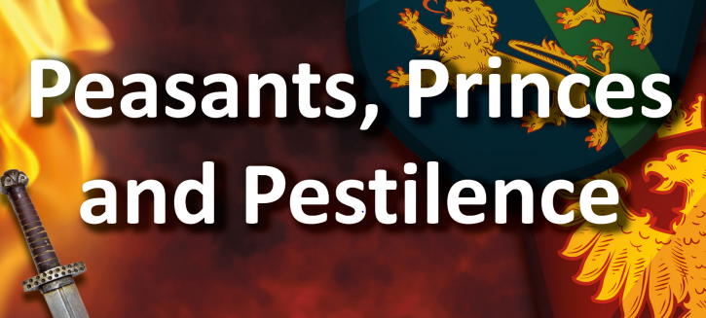

**Geography**

* Use maps, atlases, globes and digital/computer mapping to locate countries and describe features studied.
* Use fieldwork to observe, measure, record and present the human and physical features in the local area using a range of methods, including sketch maps, plans and graphs, and digital technologies.

**Art and Design**

* Improve their mastery of art and design techniques, including drawing, painting and sculpture with a range of materials (e.g. pencil, charcoal, paint, clay).

**Discrete Learning Areas:**

**English**

**Mathematics French PSHE**

**Computing Religious Education Physical Education**

|  |
| --- |
| **Discrete Learning Subjects** |
| **Main Learning Focus in English:**  **Range**: Diaries and Letters  **Speaking and listening**.   * giving short speeches and presentations, expressing their own ideas and keeping to the point   **Reading**  Maintain positive attitudes to reading and an understanding of what they read by:   * continuing to read and discuss an increasingly wide range of fiction, poetry, plays, non-fiction and reference books or textbooks. * identifying and discussing themes and conventions in and across a wide range of writing * drawing inferences such as inferring characters’ feelings, thoughts and motives from their actions, and justifying inferences with evidence. * summarising the main ideas drawn from more than 1 paragraph, identifying key details that support the main ideas   **Writing**   * selecting appropriate grammar and vocabulary, understanding how such choices can change and enhance meaning * proposing changes to vocabulary, grammar and punctuation to enhance effects and clarify meaning   **Grammar and Punctuation**   * Parenthesis * Tenses   **Spelling**   * Creating nouns using suffixes * Words using ‘or’ and ‘au’   **Handwriting**   * write legibly, fluently and with increasing speed |
| **Main Learning Focus in Mathematics:**  **Unit 9: Fractions (2)**   * Solve word problems involving fractions     **Unit 10: Fractions (3)**   * Multiply fractions and mixed numbers by fractions * Find a fraction of an amount * Understand how fractions can be operators * Solve word problems involving fractions   **Unit 11: Decimals and percentages**   * Read and write decimals up to three decimal places * Round decimals to the nearest whole number and the nearest one decimal place * Order and compare decimal numbers up to three decimal places * Write percentages as fractions and as decimals |

|  |
| --- |
| **Main Learning Focus in Computing:**  Spreadsheets |
| **Main Learning Focus in Religious Education:**  What does it mean to be Muslim in Britain today? |
| **Main Learning Focus in PSHE:**  ‘Don’t rub it in, rub it out’:  Forgiveness. Learn how to process negative emotions, disappointment and hurt. |
| **Main Learning Focus in Physical Education:** |
| **Main Learning Focus in French:**  **Classroom:**   * Recognise and repeat from memory simple classroom objects and   use the correct gender.   * Say what they have and do not have in their pencil case. * Recognise and respond to simple classroom commands and praise. |