Design & Technology
- To design a boat from recycled materials that will float.
- To select a range of appropriate materials to make a model.
- To evaluate my model.

Science
- Sort and grade a range of materials for a
specific property.
- Describe how shape of some materials can be
changed by twisting, bending, squashing or
stretching.
St Luke’s CE Primary – Curriculum Web
Year 2 Autumn 1 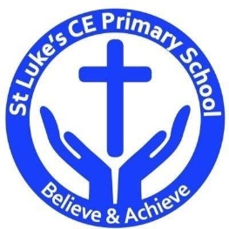

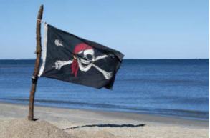

Geography
- Name and locate the capital cities of the United Kingdom and its surrounding seas.
- Draw simple maps or plans using symbols for a key.

History
- Use the stories of famous historical figures to compare aspects of life in different times.
- Use the stories of famous historical figures to
compare aspects of life in different times.

Land Ahoy

Discrete Learning Areas:
English Music
Mathematics PSHE
Computing Religious Education Physical Education

Discrete Learning Subjects
Main Learning Focus in English:
Range: Fiction – Jake’s First day Non-Chronological report – Pirates & Grace Darling.
Speaking and listening.
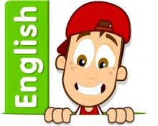
Participation in class and group Discussions explaining and justifying Opinions about texts
Reading
Shared Reading – reading the class book
Guided Reading – reading with the teacher in small groups Individual reading (from the school schemes)
Using reading skills to obtain information
Reading comprehension
Writing
- I can plan my writing by writing down my ideas or talking about them.
- I can write the correct spelling and punctuation in simple sentences I hear my teacher say.
- I can use capital letters and full stops to show where sentences start and end and sometimes use question marks.
Grammar and Punctuation
- Use co-ordination (using or, and, but) and some subordination (using when, if, that, because) to join clauses.
- Use the progressive form of verbs in the present and past tense to make actions in progress e.g. she is drumming, he was shouting.
- Use present and past tense mostly correctly.
Spelling
- Spellings linked to Read, Write Inc phonics.
Handwriting
- Form lower-case letters of the correct size relative to one another using tails and flicks.
- Write capital letters and digits of the correct size, orientation and relationship to one another and to lower case letters.
Main Learning Focus in Mathematics:
Multiplication
- Counting in 10’s, 5’s and 2’s.
- Making equal groups
- Adding equal groups
- Making simple arrays
- Making doubles
- Solving word problems
Division
- Making equal groups
- Sharing equally
- Solving problems.
Time
Maths interventions:

- Halves and quarters
- Position and direction
- Numbers to 100
- Money

- Tell the time to the hour and half past the hour
- Comparing time
- Solving problems.
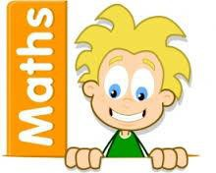
Numbers to 100:
Counting objects to 100.
Representing numbers to 100.
Tens and ones.
Representing numbers on a place value grid.
Comparing numbers.
Ordering numbers.
Counting in 2s, 5s and 10s.
Counting in 3s.

Main Learning Focus in Computing:
Coding and Bee bots
To understand what an algorithm is.
To create a computer program using simple algorithms.
To know what debugging means.
To understand the need to test and debug a program repeatedly.
To debug simple programs.
Main Learning Focus in Religious Education:

Who is a Christian and what do they believe?
- Talk about the fact that Christian believe in God and follow the examples of Jesus.
- Recognise some Christian symbols and images used to express ideas about God.
- Talk about some simple ideas about Christian beliefs about God and Jesus.
- Re-tell a story that shows what Christians might think about God.
- Talk about the issues of good and bad, right and wrong arising from stories.
- Ask some questions about believing in God and offer some ideas of their own.
- Make links between what Jesus taught and what Christians believe and do.
Main Learning Focus in PSHE:

- F.R.E.S.H – The knowledge to make healthy choices and create a positive relationship with physical activity.
- Get HeartSmart - Learn what it is to be HeartSmart and how we can Power ON to love ourselves and others well.
Main Learning Focus in Physical Education:
Work will include individual, group and paired activities.

Football and athletics

Health and well-being

Main learning Focus in Music:
Friendship Song by Joanna Mangona and Pete Readman
- Listen and Appraise the Friendship Song and other songs about friendship.
- Musical Activities - learn and/or build on knowledge and understanding about the interrelated dimensions of music.
- Perform the Song - perform and share learning.

