St Luke’s CE Primary
Autumn 2
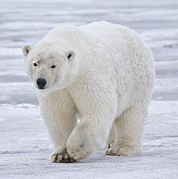

Frozen Kingdom

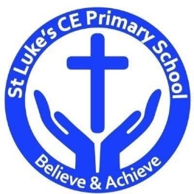

Geographical Contextual Learning
- Can they describe and understand key aspects of human geography?
- Identify the position and significance of latitude, longitude, Equator, Northern and Southern hemispheres, The tropics, Arctic and Antarctic Circles and GMT.
- Understand geographical similarities and differences between the UK and another region.
St Luke’s CE Primary – Contextual Learning Unit Features of the Polar Regions
Lead Subject Focus: Geography Subsidiary Learning Focus: Science
Discrete Learning Areas:
English Music
Mathematics French PSHE
Computing Religious Education Physical Education
Design & Technology
- Select and use from a wider range of materials (build an igloo).

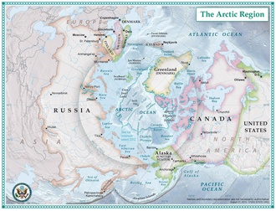

Science
- Identify how plants and animals are adapted to suit their environment.
- Describe how living things are classified into broad groups.
- Record data and results of increasing complexity.

Historical Contextual Learning
- To learn about an aspect or theme in British history that extends pupils’ chronological knowledge beyond 1066.
Art
- Improve mastery of art and design techniques.
- Create sketch books from observations and improve.

Discrete Learning Subjects
Main Learning Focus in English:
Range: Persuasive writing; newspaper articles; information texts. Activities will include:
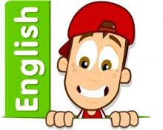
Speaking and listening.
Participation in class and group discussions Explaining and justifying opinions about texts Discussing information inferred from a text
Reading
Shared Reading – reading The Polar Bear Explorers’ Club
Guided Reading – reading with the teacher in small groups Individual reading – follow-up tasks from guided reading sessions
Focus on using information from the text to build written responses
Writing
Developing writing for a range of purposes and audiences
Using appropriate grammar and vocabulary for specific genres of writing.
Writing non-fiction texts: newspaper articles; information texts; persuasive letters.
Structuring different texts
Grammar and Punctuation
Grammatical structures used in more formal writing.
Punctuating sentences accurately with the full range of punctuation taught at KS2.
Using active and passive voice.
Spelling
Developing a range of spelling strategies Using words with spelling patterns from Y5&6 list
Using knowledge of prefixes and suffixes to spell words
Handwriting
Writing legibly with speed and fluency
Main Learning Focus in Mathematics:
Children will learn to:
- Compare and order fractions, including fractions > 1
- Use all four operations with fractions.
- Recall equivalent fractions, decimals and percentages.
- Find proportions of amounts including fractions and percentages.
- Share unequal amounts into ratios.
- multiply simple pairs of proper fractions, writing the answer
- in its simplest form (e.g. 1/4 × 1/2 = 1/8)
- divide proper fractions by whole numbers (e.g. 1/3 ÷ 2 = 1/6
- ).
- associate a fraction with division to calculate decimal
- fraction equivalents (e.g. 0.375) for a simple fraction (e.g.
- 3/8)
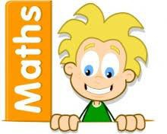
- express missing number problems algebraically
- use simple formulae expressed in words
- generate and describe linear number sequences
- find pairs of numbers that satisfy number sentences
- involving two unknowns.
- enumerate all possibilities of combinations of two variables

Main Learning Focus in Science: Adaptation and Evolution
Identify how plants and animals are adapted to suit their environment.
Describe how living things are classified into broad groups.
Record data and results of increasing complexity.
Main Learning Focus in Computing: We are programmers use a range of software to accomplish given goals.
Use search technologies effectively.
Understand computer networks including the internet.
Main Learning Focus in Religious Education: meditation
- What is meditation?
- Why do people meditate?
- What is prayer?
- Why do people use prayer as meditation?
Main Learning Focus in PSHE:
Begin to develop confidence and responsibility
Preparing to play an active role as citizens
Discuss a healthy, safe lifestyle

Specialist Taught Subjects:
Main Learning Focus in Physical Education:
Work will include individual, group and paired activities Leading simple invasion, net and striking and fielding games
Developing a range of throwing and catching techniques for basketball Keeping score, developing rules and simple tactics within games
Recognising good performance and using this to improve skills
Record and discuss how our bodies feel during and after exercise and the benefits
Main Learning Focus in French:
The weather
Main learning Focus in Music:
Brass instruments

