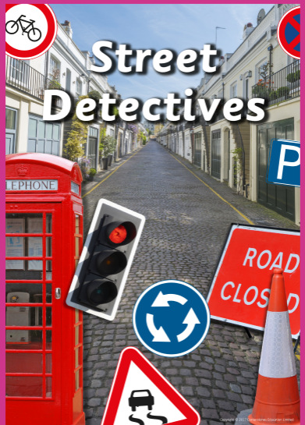
St Luke’s CE Primary – Curriculum Web
Year 2 Autumn 2 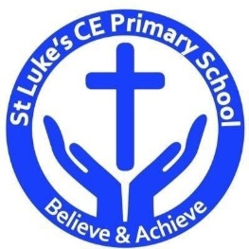
Geography
Describe and compare human and physical features seen in their local environment and other places in the world.
Identify and describe geographical human and physical features using an aerial photograph.
Draw simple map r plans using symbols for a key.

History
Describe how people, places and events in their own locality have changed over time.
Describe changes in the local area during their own lifetime and that of their parents and grandparents.
Describe how people, places and events in their own locality have changed over time.

Design & Technology
Selecting tools and materials to create a street in Heywood.

Science
Relate a material’s physical properties to its uses.

Discrete Learning Areas:
English Music Mathematics PSHE
Computing Religious Education Physical Education

Discrete Learning Subjects
Main Learning Focus in English:
Range: Fiction ‘On the way home’ and ‘My Christmas Star’.
Speaking and listening.
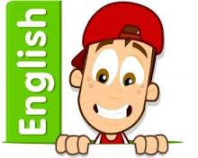
Participation in class and group Discussions explaining and justifying Opinions about texts
Reading
Shared Reading – reading the class book
Guided Reading – reading with the teacher in small groups Individual reading (from the school schemes)
Using reading skills to obtain information
Reading comprehension
Writing
- I can plan my writing by writing down my ideas or talking about them.
- I can write the correct spelling and punctuation in simple sentences I hear my teacher say.
- I can use capital letters and full stops to show where sentences start and end and sometimes use question marks.
- I can tell if a sentence is a question, command, exclamation or a statement.
- I can use description in my writing e.g the blue butterfly, plain flour, the man in the moon.
Grammar and Punctuation
- Use co-ordination (using or, and, but) and some subordination (using when, if, that, because) to join clauses.
- Use the progressive form of verbs in the present and past tense to make actions in progress e.g. she is drumming, he was shouting.
- Use present and past tense mostly correctly.
Spelling
- Read, Write Inc
Handwriting
- Form lower-case letters of the correct size relative to one another using tails and flicks.
- Write capital letters and digits of the correct size, orientation and relationship to one another and to lower case letters.
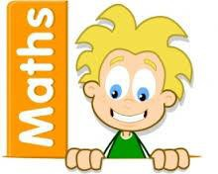
Main Learning Focus in Mathematics:
Children will learn to:

- Add a 2-digit and 1-digit number – crossing ten
- Subtract a 1-digit number from a 2-digit number – crossing ten
- Add two 2-digit numbers – crossing ten
- Subtract a 2-digit number from a 2-digit number – crossing ten
- Know my bonds to 100
- Add three 1-digit numbers
- Count money – pence and pounds/notes and coins.
- Showing equal amounts of money.
- Comparing amount of money.
Math’s afternoon intervention:

- Position and direction
- Halves and quarters
- Time
- Calculating the total amounts.
- Finding change.
- Solving 2 step word problems.
- Multiplication – making equal groups.
- Adding equal groups.
- Using arrays.
- 2, 5 and 10 times tables
- Solving problems
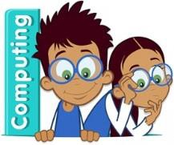
Main Learning Focus in Computing:

Questioning
- To show that the information provided on pictograms is of limited use beyond answering simple questions.
- To use 2Question (a binary tree) to answer questions.
- To use a database to answer more complex search questions. To use the Search tool to find information.
Main Learning Focus in Religious Education:

What can we learn from sacred books?
- What stories are special to us? What is a holy book?
- What did Jesus teach about God in a story?
- What did Jesus say about how to treat others?
- How are holy books treated?
- What story is special for Jewish people in the Torah?
- Which story do Muslims tell about the Prophet Muhammad?
- What can be learnt from the story of Jonah? What is special about Jonah?

Christianity – The Christmas Story.

Main Learning Focus in PSHE:

- HeartSmart – Don’t forget to let love in!
Main Learning Focus in Physical Education:
Work will include individual, group and paired activities.

Football and athletics

Health and well-being

Main learning Focus in Music:

Ho, ho, ho – Charanga
Christmas songs

Main learning Focus in French:
Greetings
Numbers to 10 in French.

