St Luke’s CE Primary – Curriculum Overview
Year 1 - Autumn 1 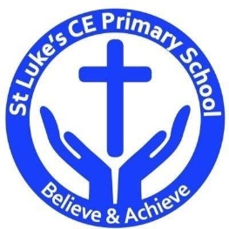

Curriculum Approach
- Learning reviewed daily (retrieval practice);
- New content taught in small chunks;
- Effective teacher questioning;
- Lots of teacher modelling;
- Regular opportunities for children to think, apply and practise key skills and knowledge;
- Support for difficult tasks;
- Develop long term memory, whilst respecting the limitations of the working memory.

Curriculum Aims
The purpose of our curriculum is to:
- enable children to become confident, resourceful, enquiring and independent learners;
- foster children’s self-esteem and help them build positive relationships with other people;
- develop children’s self-respect and encourage children to respect the ideas, attitudes, values and feelings of others;
- show respect for all cultures and, in so doing, to promote positive attitudes towards other people;
- enable children to understand their community and help them feel valued as part of this community;
- help children grow into reliable, independent and positive citizens for the 21st century.

Discrete Learning Subjects
Main Learning Focus in English:

Fiction: The Train Ride

Activities will include:
Speaking and listening.
Participation in class and group discussions Explaining and justifying opinions about texts Learning new drama skills
Reading
Shared Reading – reading an enlarged text with the class Guided Reading – reading with the teacher in small groups
Writing
Planning and structuring a narrative text
Improving story writing skills
Grammar and Punctuation
Revising the use of capital letters, full stops and finger spaces
Adding an adjective to a simple sentence
Ensuring their sentences make sense by checking
Spelling
Developing a range of spelling strategies Using sounds from RWI Set 1 and Set 2
Spelling some RWI red words
Handwriting
Revising basic letter formation
Looking at tails and flicks

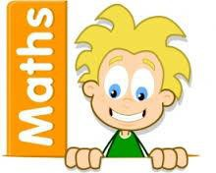
Main Learning Focus in Mathematics:
Numbers to 10; Part-Whole within 10, Addition and
subtraction within 10

Children will learn to:

- Count to and across 100, forwards and backwards, beginning with 0 or 1, or from any given number
- count, read and write numbers to 100 in numerals; count in multiples of twos, fives and tens
- given a number, identify one more and one less
- identify and represent numbers using objects and pictorial representations including the number line, and use the language of: equal to, more than, less than (fewer), most, least
- read and write numbers from 1 to 20 in numerals and words

- read, write and interpret mathematical statements involving addition (+), subtraction (–) and equals (=) signs
- represent and use number bonds and related subtraction facts within 20

- read, write and interpret mathematical statements involving addition (+), subtraction (–) and equals (=) signs
- represent and use number bonds and related subtraction facts within 20
- solve one-step problems that involve addition and subtraction, using concrete objects and pictorial representations, and missing number problems such as 7 = ☐ – 9

Main Learning Focus in Science:
Materials

Children will learn how to:

- talk about what a material is.
- discuss what objects are made from.
- describe a material and its properties.
- predict and test which materials float and sink and talk about why.
- discover which materials are waterproof.
- predict and discover which materials are magnetic.

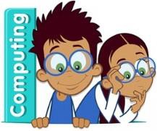
Main Learning Focus in Computing:
Children will learn about online safety and how to use
Purple Mash.

Children will learn how to:

- log in to Purple Mash using their own login.
- develop an understanding of ownership of work online
- save work into the My Work folder in Purple Mash and understand that this is a private saving space just for their work.
- find their saved work in the Online Work area of Purple Mash.
- to use the different types of topic templates in the Topics section confidently.
- explore the Tools section on Purple Mash and become familiar with some of the key icons: Save, Print, Open and New.
- log out of Purple Mash when they have finished using it and know why that is important.

Main Learning Focus in Religious Education:
Who is a Christian?

Children will learn to:

- Talk about some simple ideas about Christian beliefs about God and Jesus.
- Re-tell a story that shows what Christians might think about God, in words, drama and pictures, suggesting what it means.
- Talk about issues of good and bad, right and wrong arising from the stories.
- Ask some questions about believing in God and offer some ideas of their own.

Main Learning Focus in History:
Childhood

Children will learn to:
- Use Sequencing words, such as first, next, finally, then and after that, can be used to order information chronologically.
- Understand historical concepts such as continuity and change, cause and consequence, similarity, difference and significance, and use them to make connections

- Understand that a family tree is a diagram that shows the relationship between people in several generations of a family.
- Order information on a timeline.
- Describe an aspect of everyday life within or beyond living memory.
- Express an opinion about a historical source.

Main Learning Focus in PSHE:

Children will learn to:

- to recognise what they like and dislike, how to make real, informed choices that improve their physical and emotional health
- to recognise that choices can have good and not so good consequences
- to recognise that their behaviour can affect other people
- to recognise when people are being unkind to them or others, how to respond, who to tell and what to say about good and not so good feelings, a vocabulary to describe their feelings to others and to develop simple strategies for managing feelings

Main Learning Focus in Physical Education:

Children will learn to:

Main learning Focus in Music:

Children will learn to:

