St Luke’s CE Primary
Reception

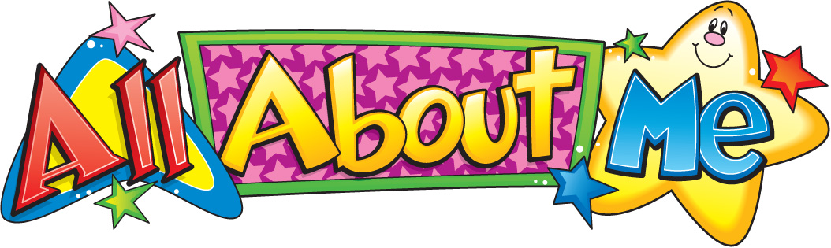

Autumn 1

All About Me

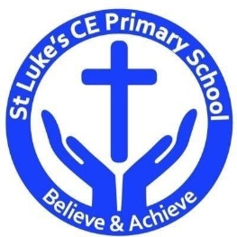

Physical Development
- Zip coat up, fasten shoes and get changed for PE independently
- Use large PE apparatus and try new and different ways of moving
- Use small and large equipment and one-handed tools
- Promote fine motor control, hand/eye coordination by using threading activities, puzzles, small construction, etc.
- Repeat patterns such as in action rhymes and finger play
- Move with control and co-ordination in a range of ways

St Luke’s CE Primary – Contextual Learning Unit on All About Me
Lead Subject Focus: Personal, Social and Emotional Development
Subsidiary Learning Focus: Literacy, Communication and Language and Physical Development
Personal, Social and Emotional Development
- Introduce classroom/ school rules and routines showing understanding of other people’s needs including the adults who work in the setting
- Introduce circle time and calendar activities
- Share own family experiences with class during circle time
- Try out new activities and select resources independently
- Learn how to use the environment appropriately e.g. tiding up
- Show awareness of own and others needs
- Encourage children to play alongside and interact with other children who have similar interests to them

Literacy
- Listen to and distinguish initial sounds in own name and those of others
- Draw and paint sometimes giving meaning to marks
- Ask questions appropriately and listen to the response
- Recognise set 1 sounds in Read, Write, Inc
- Join in with ‘Fred games’
- Begin to recognise/trace/copy/ write own name
- Begin to blend and segment CVC words
- To hold a book correctly and turn one page at a time
- To read books without words and then books with simple words and phrases

Communication and Language

- Respond to simple instructions and two part instructions
- Listen attentively to a range of stories
- Begin to join in familiar nursery rhymes and songs
- Begin to join in with repeated phrases within stories
- Use words and/or gestures appropriately
- Communication effectively with other children and staff
- To sit quietly during activities
- To follow a story without pictures

Main Learning Focus – Mathematics
- Recognise numbers to 5
- Count objects accurately up to 5
- Subitise up to 5
- Begin to use the language of more and less
- Recognise 3D and 2D shapes
- Discuss the shapes and their properties
- Begin to understand ‘one more’ and ‘one less’
- To use positional language accurately
- To begin to understand spatial awareness
- To begin to break a whole into two parts
Main Learning Focus – Expressive Art and Design
- Be introduced to a wide variety of art materials, their purpose and how to use them safely
- Explore 2d and 3d art
- Observational drawings/paintings of faces using mirrors and window panels, noting similarities and differences
- Explore different materials/ textures to create collages of own face
- Make 3D structures with construction
- Explore music, sounds and sing songs

Main Learning Focus – Understanding the world
- Look at the past and present in relation to ‘self’
- Investigate and use construction materials by themselves
- Ask why things happen and how they work
- Use ICT to support learning- create self –portrait on IWB
- Talk about self and immediate family in circle time

