St Luke’s CE Primary – Curriculum Overview
Year 5 Autumn 1

Curriculum Approach
- Learning reviewed daily (retrieval practice);
- New content taught in small chunks;
- Effective teacher questioning;
- Lots of teacher modelling;
- Regular opportunities for children to think, apply and practise key skills and knowledge;
- Support for difficult tasks;
- Develop long term memory, whilst respecting the limitations of the working memory.

Curriculum Aims
The purpose of our curriculum is to:
- enable children to become confident, resourceful, enquiring and independent learners;
- foster children’s self-esteem and help them build positive relationships with other people;
- develop children’s self-respect and encourage children to respect the ideas, attitudes, values and feelings of others;
- show respect for all cultures and, in so doing, to promote positive attitudes towards other people;
- enable children to understand their community and help them feel valued as part of this community;
- help children grow into reliable, independent and positive citizens for the 21st century.

Discrete Learning Subjects
Main Learning Focus in English:

Range: Narratives

Speaking and listening.
- giving short speeches and presentations, expressing their own ideas and keeping to the point
Reading
Maintain positive attitudes to reading and an understanding of what they read by:
- continuing to read and discuss an increasingly wide range of fiction, poetry, plays, non-fiction and reference books or textbooks.
- identifying and discussing themes and conventions in and across a wide range of writing
- drawing inferences such as inferring characters’ feelings, thoughts and motives from their actions, and justifying inferences with evidence.
- summarising the main ideas drawn from more than 1 paragraph, identifying key details that support the main ideas
Writing
- selecting appropriate grammar and vocabulary, understanding how such choices can change and enhance meaning
- in narratives, describing settings, characters and atmosphere and integrating dialogue to convey character and advance the action
- proposing changes to vocabulary, grammar and punctuation to enhance effects and clarify meaning

Grammar and Punctuation
- Using relative clauses beginning with who, which, where, when, whose, that
- Use of inverted commas and other punctuation to indicate direct
- Use modal verbs in writing

Spelling
- continue to distinguish between homophones and other words which are often confused
- spell some words with ‘silent’ letters [for example, knight, psalm, solemn]

Handwriting
- write legibly, fluently and with increasing speed

Main Learning Focus in Mathematics:
Children will learn to:

Unit 1 and 2: Place value within 1,000,000
• read, write, order and compare numbers to at least 1 000 000 and determine the value of each digit
• solve number problems and practical problems that involve all of the above
• round any number up to 1 000 000 to the nearest 10, 100, 1000, 10,000 and 100,000

Unit 3: Addition and Subtraction
- add and subtract whole numbers with more than 4 digits, including using formal written methods (columnar addition and subtraction)
- use rounding to check answers to calculations and determine, in the context of a problem, levels of accuracy
- add and subtract numbers mentally with increasingly large numbers
- estimate and use inverse operations to check answers to a calculation
- solve addition and subtraction multi-step problems in contexts, deciding which operations and methods to use and why

Main Learning Focus in Science:
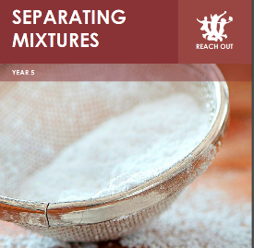
• Describe what a pure substance is
• Give examples of some pure substances
• Explain how we can tell if something is pure
or not
• Know what a mixture is
• Give examples of mixtures of substances from
the same state
• Describe examples of mixtures with
substances in different states
• Describe what a formulation is
• Explain why formulations are useful
• Give examples of formulations
• Describe how to remove large solid particles
from a mixture
• Describe how to remove insoluble
substances from a mixture
• Describe how to remove soluble substances
from a mixture
• Define solution, solute, solvent, soluble and
insoluble
• Describe how to use filtration to separate
some mixtures
• Describe how you can use evaporation to
separate some mixtures
• Carry out separation of substances in river
water
• Evaluate how the method for separating
substances in river water
• Suggest how an environmental scientist
could check the water quality in a river
Main Learning Focus in Geography:
- What are slums?
- Where do slums form?
- Where are the biggest slums located?
- Why do people move to cities?
- Why are slums are located around cities?
- How do slums develop?
- What classifies a slum?
- What challenges do slum communities face?

Main Learning Focus in Computing:

- Online Safety
- 3D modelling
Main Learning Focus in Religious Education:
Why do some people believe God exists?
- This investigation enables pupils to learn in depth from different religious and non-religious groups about belief in God. Pupils enquire into the key question- raising questions about the nature and existence of God focusing on Christian ideas about God.
Main Learning Focus in French:

- Masculine and feminine nouns
- French food
- Numbers to 60
- Simple phrases
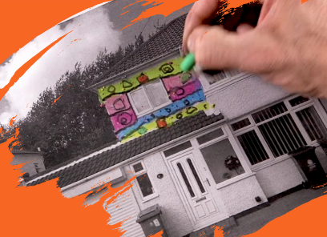
Main Learning Focus in Art:

- Formal elements: Architecture
Children learn how to draw from observation, create a print and draw from different perspectives. They learn about the role of an architect and are challenged to consider why houses look the way they do and if there is scope to change and improve them.

Main Learning Focus in PE:

• Health related fitness
• Football

Main Learning Focus in PSHE:

- Get Heart smart
It will teach children what it is to be Heart Smart
and how we can ‘Power ON’ to love ourselves and others well.

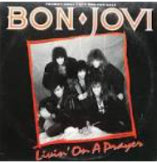
Main Learning Focus in Music:

Livin’ on a Prayer

- Listening and appraising Rock music
- Singing in unison
- Learning about pulse, pitch and rhythym

