St Luke’s CE Primary – Curriculum Overview
Year 2 Autumn 1 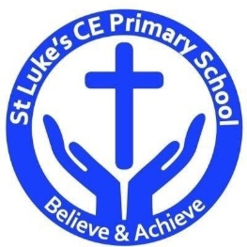

Curriculum Approach
- Learning reviewed daily (retrieval practice);
- New content taught in small chunks;
- Effective teacher questioning;
- Lots of teacher modelling;
- Regular opportunities for children to think, apply and practise key skills and knowledge;
- Support for difficult tasks;
- Develop long term memory, whilst respecting the limitations of the working memory.

Curriculum Aims
The purpose of our curriculum is to:
- enable children to become confident, resourceful, enquiring and independent learners;
- foster children’s self-esteem and help them build positive relationships with other people;
- develop children’s self-respect and encourage children to respect the ideas, attitudes, values and feelings of others;
- show respect for all cultures and, in so doing, to promote positive attitudes towards other people;
- enable children to understand their community and help them feel valued as part of this community;
- help children grow into reliable, independent and positive citizens for the 21st century.

Discrete Learning Subjects
Main Learning Focus in English:
Range: Non-fiction non chorological report Pirates. Fiction The owl who was afraid of the dark.
Speaking and listening.
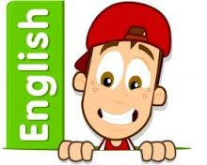
Participation in class and group Discussions explaining and justifying Opinions about texts
Reading
Shared Reading – reading the class book
Guided Reading – reading with the teacher in small groups Individual reading (from the school schemes)
Using reading skills to obtain information
Reading comprehension
Writing
- I can plan my writing by writing down my ideas or talking about them.
- I can write the correct spelling and punctuation in simple sentences I hear my teacher say.
- I can use capital letters and full stops to show where sentences start and end and sometimes use question marks.
- I can tell if a sentence is a question, command, exclamation or a statement.
- I can use description in my writing e.g the blue butterfly, plain flour, the man in the moon.
Grammar and Punctuation
- Use co-ordination (using or, and, but) and some subordination (using when, if, that, because) to join clauses.
Spelling
- Read, Write Inc red words.
Handwriting
- Form lower-case letters of the correct size relative to one another using tails and flicks.
Write capital letters and digits of the correct size, orientation and relationship to one another and to lower case letters.

Main Learning Focus in Mathematics:
Children will learn to:
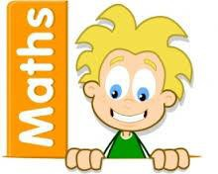
- Counting objects to 100.
- Representing numbers to 100.
- Tens and ones.
- Representing numbers on a place value grid.
- Comparing numbers
- Ordering numbers
- Counting in 2s, 5s and 10s.
- Counting in 3s.

French passport
Main Learning Focus in Science:
- What is light?
- How can we see objects?
- What is between night and day?
- Which materials are reflective?
- How are shadows formed?
- How can you change the size of a shadow?

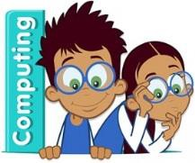
Main Learning Focus in Computing:

Online safety and Coding.
- Introduction to coding
- Introduction to backgrounds and characters.
- Making a character move left and right.
- Introduction to collision detection.
- To use repeat and timer commands.
- Debugging.
- To explore the possible actions of different types of objects.
Main Learning Focus in Religious Education:
Who is a Christian and what do they believe?
- Describe what they think about what Christians believe and think is important
- Talk about their own ideas about God
- Retell a story that shows what Christians might think about God
- Talk about some ways that Christians describe God and Jesus
- Talk about why God and Jesus are important for Christian people
- Think, talk about and ask some thoughtful questions about how the Bible influences Christians and what influences them
- Describe some beliefs and stories that are important to Christians.
Main Learning Focus in PSHE:

HeartSmart – Get Heartsmart
- Many choices we make can help or hurt our own and others hearts
- Describe ways we can use our power in positive and negative ways
- Can the children explain how the decisions they make affect their reputation
- Make the link between our hearts and our actions, words and behaviours
- Families may all look different but they should all be places of love and security
- Care for our school environment by conserving energy.
Main Learning Focus in History Movers and shakers

- Exploring impact
- Sorting and grouping
- Timelines
- Significant people - Christopher Columbus
- Significant people – Niel Armstrong
- Timelines of significant people’s lives
- Exploration changes
Main learning Focus in Music:
Hands, feet, heart

- Find the pulse as you are listening to the music.
- Find the pulse
Perform and share
Main Learning Focus in Physical Education:
- Yoga

