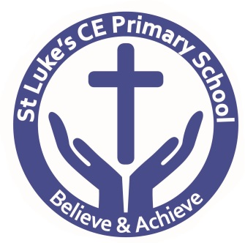
St Luke’s CE Primary School
Queen’s Park Road, Heywood, Lancs, OL10 4XB

Telephone: 01706 369443

Web: www.stlukesce.co.uk
Email: office@stlukesceprimary.co.uk

Head teacher: Mrs K. Farrall

Uniform Check List

Dear Parent/Guardian,

Your child’s uniform can be purchased from Frank Blakely & Son Ltd. You can contact them via the telephone on 01706 692428 or visit their website: www.shockabclubshop.co.uk. Their opening hours are Monday to Friday 8am -5pm. Alternatively, you can also purchase from Moses Uniform Shop on, 21-23 Oldham Road, Rochdale, OL16 1UA. You can contact them via the telephone on 01706 644 447, e-mail moseswear@googlemail.com or visit their website at www.moseswear.com. They are open Monday –Friday 9.00-5.30pm and Saturday 9.00-5.00pm.

Your child will need the following:
- Royal blue round neck sweatshirt (with school logo – optional)
- Royal blue v neck sweatshirt (with school logo optional - Year 6 only)
- Royal blue cardigan (with school logo – optional)
- Royal blue fleece with school logo (optional)
- Grey or black pinafore
- Grey or black skirt or trousers
- Book bag (provided for Reception class by school when forms are completed)
- Waterproof coat
- School tie (Year 6 only – school will provide 1 tie free of charge)
- Blue checked summer dress

P.E. kit
- White t-shirt with or without school logo
- Plain navy blue or plain black tracksuit (optional with school logo available from Frank Blakeley)
- Royal blue or navy shorts
- Trainers
- No football kits or branded tracksuits

Yours sincerely

K Farrall
Headteacher

