St Luke’s CE Primary – Curriculum Overview
Year 2 Autumn 1 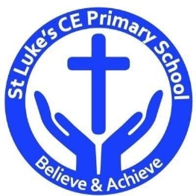

Curriculum Approach
- Learning reviewed daily (retrieval practice);
- New content taught in small chunks;
- Effective teacher questioning;
- Lots of teacher modelling;
- Regular opportunities for children to think, apply and practise key skills and knowledge;
- Support for difficult tasks;
- Develop long term memory, whilst respecting the limitations of the working memory.

Curriculum Aims
The purpose of our curriculum is to:
- enable children to become confident, resourceful, enquiring and independent learners;
- foster children’s self-esteem and help them build positive relationships with other people;
- develop children’s self-respect and encourage children to respect the ideas, attitudes, values and feelings of others;
- show respect for all cultures and, in so doing, to promote positive attitudes towards other people;
- enable children to understand their community and help them feel valued as part of this community;
- help children grow into reliable, independent and positive citizens for the 21st century.

Discrete Learning Subjects
Main Learning Focus in English/phonics (Read, Write Inc.)

Speaking and listening.
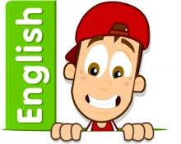
- Participation in class and group discussions
- Explaining and justifying
- Opinions about texts
Reading
- Reading during phonics lesson
- Using reading skills to obtain information
- Reading comprehension
Writing
- I can plan my writing by writing down my ideas or talking about them.
- I can write the correct spelling and punctuation in simple sentences I hear my teacher say.
- I can use capital letters and full stops to show where sentences start and end and sometimes use question marks.
- I can tell if a sentence is a question, command, exclamation or a statement.
- I can use description in my writing e.g the blue butterfly, plain flour, the man in the moon.
Grammar and Punctuation
- To use ‘and’ to join clauses
- Different sentence types – statements, commands, exclamations, questions
- Commas in a list
Spelling
- Read, Write Inc red words.
Handwriting
- Form lower-case letters correctly following Read, Write Inc, scheme.
Main Learning Focus in Mathematics:
Children will learn to:
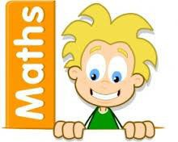
- Counting objects to 100.
- Representing numbers to 100.
- Tens and ones.
- Representing numbers on a place value grid.
- Comparing numbers
- Ordering numbers
- Counting in 2s, 5s and 10s.
- Counting in 3s.

French passport
Main Learning Focus in Science:
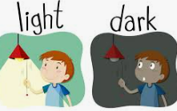
- What is light?
- How can we see objects?
- What is between night and day?
- Which materials are reflective?
- How are shadows formed?
- How can you change the size of a shadow?
Main Learning Focus in Computing:
Online safety and Coding.
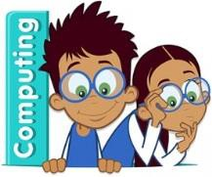
- Introduction to coding
- Introduction to backgrounds and characters.
- Making a character move left and right.
- Introduction to collision detection.
- To use repeat and timer commands.
- Debugging.
- To explore the possible actions of different types of objects.

Main Learning Focus in Religious Education:
Who is a Christian and what do they believe?
- Describe what they think about what Christians believe and think is important
- Talk about their own ideas about God
- Retell a story that shows what Christians might think about God
- Talk about some ways that Christians describe God and Jesus
- Talk about why God and Jesus are important for Christian people
- Think, talk about and ask some thoughtful questions about how the Bible influences Christians and what influences them
- Describe some beliefs and stories that are important to Christians.
Main Learning Focus in History: Great Fire of London
- How can we safely build a fire?
- What were the problems with London in 1666?
- What happened and how do we know?
- What did eyewitnesses say about the Great Fire?
- What are causes and consequences?
- Why did the Great Fire of 1666 spread so easily?
Main Learning Focus in Art: Tell a story
- To develop a range of mark-making techniques.
- I can experiment with charcoal to draw different marks.
- I can understand a word and explain how I can draw it.
- I can describe how an object feels.
- I can try out different drawing materials.
- To develop observation drawing.
- I can recognize and describe shapes in an object to start a drawing.
- I can look carefully to add details.
- To understand how to apply expressions to illustrate a character.
- I can sketch a new character, adding expressions, details and texture.
- To develop illustrations to tell a story.
- I can create and draw imaginary scenes.
Main Learning Focus in Design and technology: Hidden Sugars
- To know what makes a balanced diet
- To taste test food combinations.
- To design a healthy wrap.
- To make a healthy wrap.
Main Learning Focus in PSHE: Me and my relationship
- Our ideal classroom
- How are you feeling today?
- Bullying or teasing?
- Don’t do that!
- Types of bullying
- Being a good friend
- Let’s all be happy!
Main learning Focus in Music:
Hands, feet, heart

- Find the pulse as you are listening to the music.
- Find the pulse
- Perform and share

