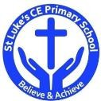
St Luke’s CE Primary – Curriculum Overview

Year 5 Summer 1

Curriculum Aims
The purpose of our curriculum is to:
- enable children to become confident, resourceful, enquiring and independent learners;
- foster children’s self-esteem and help them build positive relationships with other people;
- develop children’s self-respect and encourage children to respect the ideas, attitudes, values and feelings of others;
- show respect for all cultures and, in so doing, to promote positive attitudes towards other people;
- enable children to understand their community and help them feel valued as part of this community;
- help children grow into reliable, independent and positive citizens for the 21st century.
Curriculum Approach
- Learning reviewed daily (retrieval practice);
- New content taught in small chunks;
- Effective teacher questioning;
- Lots of teacher modelling;
- Regular opportunities for children to think, apply and practise key skills and knowledge;
- Support for difficult tasks;
- Develop long term memory, whilst respecting the limitations of the working memory.

Discrete Learning Subjects
Main Learning Focus in English:

Range: Narrative poem and non-chronological report
Reading
Maintain positive attitudes to reading and an understanding of what they read by:
- continuing to read and discuss an increasingly wide range of fiction, poetry, plays, non-fiction and reference books or textbooks.
- identifying and discussing themes and conventions in and across a wide range of writing
- drawing inferences such as inferring characters’ feelings, thoughts and motives from their actions, and justifying inferences with evidence.
- summarising the main ideas drawn from more than 1 paragraph, identifying key details that support the main ideas
Writing
- selecting appropriate grammar and vocabulary, understanding how such choices can change and enhance meaning
- In poetry, using a range of techniques to add description
- Using the correct techniques to make writing informative
- Proposing changes to vocabulary, grammar and punctuation to enhance effects and clarify meaning

Grammar and Punctuation
- Verbs
- Modal verbs
- Adverbs
- Pronouns
- Relative pronouns
- Determiners
Spelling
- Homophones
- Unstressed vowels and consonants
- Words with silent letters
- Words from other countries

Handwriting
- write legibly, fluently and with increasing speed
Main Learning Focus in Mathematics:
Children will learn to:

Unit 12: Decimals
- solve problems involving number up to three decimal places
- read, write, order and compare numbers with up to three decimal places
- recognise and use thousandths and relate them to tenths, hundredths and decimal equivalents

Unit 13: Properties of shape
  - know angles are measured in degrees: estimate and compare acute, obtuse and reflex angles
  - draw given angles, and measure them in degrees (°)
  - angles at a point on a straight line and 1/2 a turn (total 180°)
  - angles at a point and one whole turn (total 360°)
  - use the properties of rectangles to deduce related facts and find missing lengths and angles

Main Learning Focus in Science:

Humans and Animals over time

- What is the theory of evolution?
- How do fossils provide evidence for evolution?
- How have different animal kingdoms developed over time?
- Which types of organism have lived over each era of time?
- What impact have homo sapiens had on the organisms over time?
- What is the likely impact of humans on organisms in the future?
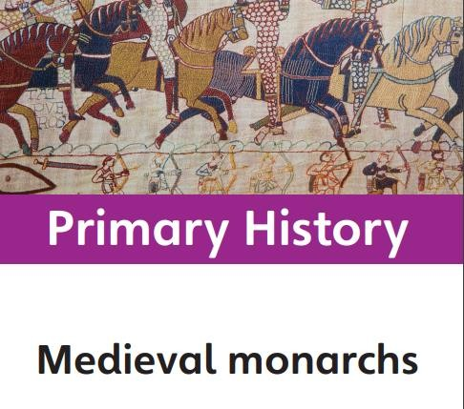
Main Learning Focus in History: Medieval Monarchs
Why was there a succession crisis in 1066? Who was responsible for the death of Thomas Becket?
Which king was worse, John or Richard? What makes a great medieval monarch?
How did power change during the medieval period?
Main Learning Focus in Computing:

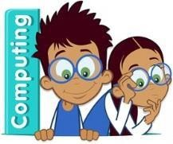
- Databases
Main Learning Focus in Religious Education:

What does it mean to be a Muslim in Britain today?

This unit enables pupils to learn in depth from different religious and spiritual ways of life about being a follower of the Muslim religion. Pupils explore the five pillars of Islam and the importance of these to Muslim believers. Pupils will gain a greater understanding of Islam and what we can learn from its beliefs, values and ideas. This investigation provides an opportunity to learn about the Qur’an.
Main Learning Focus in French:

Les Jeux Olympiques
- Know key facts from the history of the Olympics and from the modern games in French.
- Remember at least three of the nouns for the ten sports from memory, including their correct spelling.
- Conjugate the JE form of the verb FAIRE. Use this to say that I play a sport in French.

Main Learning Focus in Art:

Craft and Design – Architecture

- Sketch a house from first-hand or second-hand observation.
- Use basic shapes to place key features and form the composition, measuring to work out proportions.
- Notice small details to incorporate into the drawing by observing.
- Select a section of their drawing that creates an interesting composition, with a variety of patterns, lines and texture.
- Follow steps to create a print with clear lines, with some smudging.
- Purposefully evaluate their work, demonstrating what went well and what could be improved.
- Create a building design based on a theme or set purpose.
- Draw a plan view or front elevation of their building, annotating the key features.
- Discuss Hundertwasser’s work and recognise his style.
- Create a factual presentation about Hundertwasser in a visually pleasing way.
- Show understanding of what a monument is for by designing a monument that symbolises a person or event.
- Describe their monument and explain their choices.
- Give constructive feedback to others about their monument designs
Main Learning Focus in PE:

- Dance
- Cricket
Main Learning Focus in PSHE:

- Managing difficult feelings
- Managing change

